Accessibility guidelines
for HTML and CSS
Date | Version | Author | Statuts / comments
Nov. 3rd, 2018 | 3.0 | Atalan
Jan 21, 2019 | 3.1 | Atalan | Minor changes in text of the 6.2 guideline.
August 10, 2020 | 4.0 | Atalan | Major updates to ensure compliance with RGAA 4 and WCAG 2.1 (levels A and AA).
In partnership with :
Air Liquide – Atos – BNP Paribas – Capgemini – EDF – Generali – L’Oréal – SFR – SNCF – Société Générale – SPIE – Total
Observers :
AbilityNet (UK) – Agence Entreprises & Handicap – AnySurfer (Belgium) – Association des Paralysés de France (APF) – Association Valentin Haüy (AVH) – CIGREF – Design For All Foundation (Spain) – ESSEC – Handirect – Hanploi – Sciences Po – Télécom ParisTech

Table of contents
Table of contents 2
Introduction 6
Context and objectives 6
Who should read this document, and how to use it? 6
Contact 6
License agreement 7
1. General structure 8
1.1 Add structure to the header area using <header role="banner"> 8
1.2 Mark up the search field with role="search" 8
1.3 Structure the main content area with <main role="main"> 8
1.4 Structure information about the website with <footer role="contentinfo"> 9
1.5 Structure primary and secondary navigation menus with <nav role="navigation"> 9
1.6 Structure navigation menus with lists 10
Why should I structure lists? 10
1.7 Create a logical and thorough hierarchy for headings, using <h1> to <h6> tags 11
2. Page title 16
2.1 Provide a descriptive <title> element on each page 16
3. Languages 17
3.1 Provide the primary language of the page with the lang attribute on the <html> tag 17
3.2 Use the lang attribute to indicate a change of language 17
4. HTML Grammar and Semantics 19
4.1 Write a valid HTML code following the formal grammar rules of the DOCTYPE used 19
4.2 Use HTML elements for their semantic purpose 19
5. Links and Buttons 20
5.1 Distinguish buttons from links 20
Buttons 20
Links 20
5.2 Complete non-explicit links and buttons using hidden text, aria-label or title. 20
The aria-label attribute 20
The title attribute 21
5.3 Don't use the aria-label or title attributes on links and buttons that are already explicit 22
6. Images and Icons 23
6.1 Managing the alt attribute of the <img /> and <input type="image" /> tags 23
Decorative/ambient <img /> 23
“Simple” informative <img /> 23
“Complex” informative <img /> 24
Unlabeled <img /> links or buttons 25
<input type="image" /> 26
6.2 Managing alternative text on SVG (Scalable Vector Graphics) 26
Decorative/ambient <svg> 26
“Simple” informative <svg> 27
“Complex” informative <svg> 28
<svg> links and buttons alone 29
6.3 Managing alternative text on Icon Fonts 30
Decorative/ambient icons 30
Informative icons 30
Links or buttons icons 31
6.4 Tag images that have captions with <figure role="figure"> and <figcaption> 32
Example 1 32
Example 2 33
7. Forms 34
7.1 Use the <label> tag with the for and id attributes to label form fields with a visible name 34
7.2 Use the title attribute to label form fields that don't have a visible label 34
7.3 Use the autocomplete attribute to facilitate auto-fill 35
7.4 Add help text directly to the <label> tags 35
7.5 Add required or aria-required="true" to mandatory fields 37
7.6 Add error messages and correction suggestions directly to the <label> tag 37
7.7 Group and label related fields with <fieldset> and <legend> 39
8. Lists 41
8.1 Tag unordered lists with <ul> and <li> 41
What are the advantages? 41
8.2 Tag ordered lists with <ol> and <li> 41
What are the advantages? 42
8.3 Mark up description lists with <dl>, <dt> and <dd> 42
What are the advantages? 43
9. Tables 44
9.1 Use <caption> to tag data table captions 44
9.2 Mark up the row and column header cells with <th> 44
9.3 In simple data tables use the scope attribute to associate data cells with their corresponding headers 45
9.4 Add role="presentation" to each layout <table> 46
10. Using CSS 47
10.1 Use CSS to lay out text 47
10.2 Ensure that content can be read when images are turned off 47
10.3 Ensure that content is understandable when CSS is disabled 48
Examples 48
11. Zoom and font sizes 51
11.1 Use only relative font sizes (rem, em, %, etc.) 51
11.2 Ensure content readability even when font size is doubled 51
12. Keyboard Navigation 52
12.1 Ensure the proper functioning of the interface using either the mouse or keyboard 52
12.2 Ensure that the tab order follows the logical reading order 52
12.3 Ensure that keyboard focus is visible 53
12.4 Introduce “skip links” 53
13. Iframes 55
13.1 Populate the title attribute on each <iframe 55
14. Additional Guidelines 56
Tag block quotations using <blockquote> 56
Tag online quotations using <q> 56
Write the HTML code in a logical reading order 57
Indicate in the alternative text for visual CAPTCHA where to find the non-visual version 57
Do not use tags or attributes specific to data tables in layout table 58
Plan alternative text for each type of multimedia content (<video>, <audio>, <object>, <embed>, etc.) 58
Populate the alt attribute of each mapped image and its <area /> tags 59
In complex tables, use the headers and id attributes to associate header cells with their corresponding data cells 59
Ensure that the HTML flow is consistent from one page to the next 60
Make sure layout tables follow the right reading order 61
Additional recommendations 63
Tag abbreviations with <abbr> 63
Combine adjacent links pointing to the same page 63
In forms with multiple steps, identify the current step using aria-current="step" 64
Identify the current position in navigation systems with aria-current 65
Example in a menu 65
Example in a pagination system 66
Example in a breadcrumb trail 66
Add file format and size to all Download links and buttons 66
Update the page <title> when an error or confirmation message is displayed 67
Do not disable the zoom with the user-scalable property 68
Do not use CSS to display images that carry information 68
Logically organize the items of dropdown lists 69
Send a notification when a new window is opened 70
Use only relative sizes (rem, em, %, etc.) for media query breakpoints 71
Make sure that hidden content is translated 71

Introduction

Context and objectives
This document provides guidelines for making HTML and CSS integration more accessible.
This manual is part of a set of four complementary manuals that can be downloaded from the AcceDe Web website at www.accede-web.com:
- Graphic and functional accessibility guidelines.
- HTML and CSS accessibility guidelines (this manual).
- Main rich interface components accessibility guidelines.
- Accessibility guidelines for editors (template).

Who should read this document, and how to use it?
This document should be provided to stakeholders and/or contractors implementing the technical specifications, and HTML/CSS integration. It complements project specifications. The recommendations may be supplemented or removed depending on the context of use, such work can be carried out by the project owner.
These recommendations must be used when creating HTML/CSS. Some of them are used for dynamic content, for example, when templates are created for a content management system (CMS).
Note
The online version of these guidelines comes with many examples, links to complementary resources, etc. It is available at: www.accede-web.com/en/.

Contact
Please send any comments about this document to Atalan, the initiator of the AcceDe Web project, at the following email address: accede@atalan.ca.
You can also find more information on the Guidelines methodology of the AcceDe Web project on the website www.accede-web.com.

License agreement
This document is subject to the terms of the Creative Commons BY 3.0 license.
You are free to:
- copy, distribute and communicate the work to the public,
- change this work,
under the following conditions:
- Mention of the authorship if the document is modified:
  - You must include the Atalan and AcceDe Web logos and references, indicate that the document has been modified, and add a link to the original work at www.accede-web.com/en/.
  - You must not under any circumstance cite the name of the original author in a way that suggests that he or she endorses you or supports your use of the work without his or her express agreement.
  - You must not under any circumstance cite the name of partner companies (Air Liquide, Atos, BNP Paribas, Capgemini, EDF, Generali, L’Oréal, SFR, SNCF, Société Générale, SPIE and Total), or the organizations which have supported this initiative (AbilityNet, Agence Entreprises & Handicap, AnySurfer, Association des Paralysés de France (APF), CIGREF, Design For All Foundation, ESSEC, Handirect, Hanploi, Sciences Po and Télécom ParisTech) without their express agreement.
The Atalan and AcceDe Web logos and trademarks are registered and are the exclusive property of Atalan. The logos and trademarks of partner companies are the exclusive property of Air Liquide, Atos, BNP Paribas, Capgemini, EDF, Generali, L’Oréal, SFR, SNCF, Société Générale, SPIE and Total.

General structure

Add structure to the header area using
<header role="banner">
Mark up the main header section (i.e. logo, search field, etc.) with <header role="banner">.
Warning
While the <header> tag may be used several times in a web page, role="banner" must only be used once per web page.
Note
It is perfectly acceptable to nest several ARIA roles: <div role="search"> into <header role="banner">, for example.
<header role="banner">
<img src=" my-site-logo.png" alt="My site (logo" />
<div role="search" … > […] </div>
[…]
</header>

Mark up the search field with role="search"
The website search field must be identified with role="search".
<form role="search" … >
<input type="text" title="Keyword Search" />
<input type="submit" value="Search" />
</form>

Structure the main content area with <main role="main">
The main content area of the page must be marked up with <main role="main">.
Warning
A page must contain only one visible <main role="main"> tag.
<header role="banner">[…]</header>
<nav role="navigation">[…]</nav>
<main role="main">[…]</main>
<footer role="contentinfo">[…]</footer>

Structure information about the website with
<footer role="contentinfo">
Information about the website such as the copyright and the “Legal terms and conditions” and “Credits” links must be structured with <footer role="contentinfo">.
Warning
A page can contain only one role="contentinfo".
<header role="banner">[…]</header>
<nav role="navigation">[…]</nav>
<main role="main">[…]</main>
<footer role="contentinfo">
<ul>
<li><a href="…">Sitemap</a></li>
<li><a href="…">Credits</a></li>
<li><a href="…">Terms and Conditions</a></li>
</ul>
<p>© Company/Site name</p>
</footer>

Structure primary and secondary navigation menus with
<nav role="navigation">
Primary and secondary navigation menus must be marked up with <nav role="navigation">.
Note
The <nav> tag is reserved for website’s internal links.
For example:
- The main menu.
- The sub-menu.
- The breadcrumb.
- The search results page number.
In other words, it must not be used to mark up a list of external links, such as a list of social media links.
Tip
Good practice is to add an aria-label attribute to the <nav role="navigation"> tag to specify the type of navigation system.
<header role="banner">[…]</header>
<nav role="navigation" aria-label="Primary menu">[…]</nav>
<nav role="navigation" aria-label="Secondary menu">[…]</nav>
<main role="main">
<nav role="navigation" aria-label="You are here">[…]</nav>
[…]
</main>
<footer role="contentinfo">[…]</footer>

Structure navigation menus with lists
Use unordered list elements <ul> and <li> to mark up navigation menus.
For primary menus with several levels, be sure to nest the links appropriately:
<nav role="navigation" aria-label="Main menu">
<ul>
<li><a href="…">First menu item</a></li>
<li>
<a href="…">Second menu item</a>
<ul>
<li><a href="…">First sub-menu item</a></li>
<li><a href="…">Second sub-menu item</a></li>
</ul>
</li>
<li><a href="…">Third menu item</a></li>
</ul>
</nav>

Why should I structure lists?
- Structuring lists is important for people who use screen readers (blind and visually-impaired people). When readers come across a list, structuring enables them to:
- Navigate from list to list on a page.
- Know, from the start, the number of items on the page.
- Navigate more easily through the list:
  - Go directly to the end of the list if the content does not interest them.
  - Easily go back to the beginning of the list.

Create a logical and thorough hierarchy for headings, using <h1> to <h6> tags
On each page, headings must be tagged from <h1> to <h6>. The structure of the headings must be both logical and thorough.
In other words:
- There must not be any "jumps" or inconsistencies in the heading structure (i.e. from <h1> to <h3> without <h2> in between).
- All elements that function as headings must be marked up using heading tags.
Notes
- Several <h1> elements can be used on a page if there are primary headings.
- Good accessibility practice is to avoid using hidden headings.
Tip
To create a logical and understandable heading hierarchy, imagine the headings of the page as a "Table of Contents". Is it logical? thorough?
Note
The ARIA heading role with the aria-level attribute (with a value of 1 to 6) will override the semantics of any native HTML tag/ makes it possible to assign a title value to any HTML tag.
For example:
- <p role="heading" aria-level="1">Heading Level 1</p> is semantically equivalent to <h1>Heading Level 1</h1>.
- <div role="heading" aria-level="3">Heading Level 3</div> is semantically equivalent to <h3>Heading Level 3</h3>.
However, this technique is not optimal for accessibility, it should only be used as a last resort.
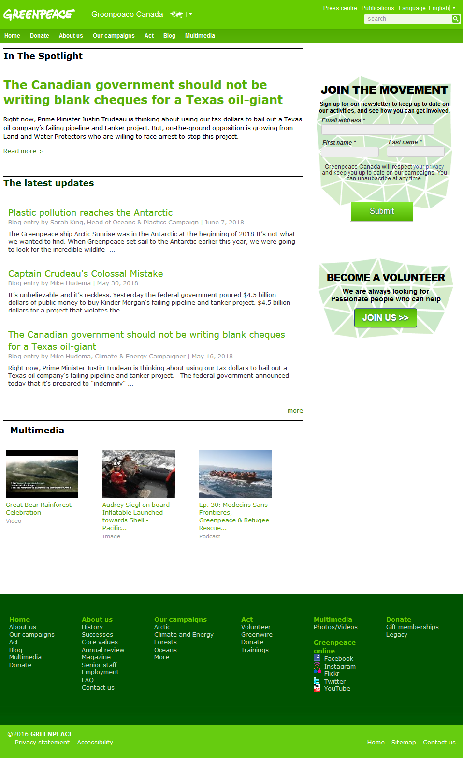
Three examples of heading structures for this page are provided below. The first two are correct, but the last one is not.

Example 1 (correct)
<h1><a href="/"><img src="GreenPeace.png" alt="GreenPeace (go back to homepage)" /></a></h1>
[…]
<h2>In the spotlight</h2>
[…]
<h3>The Canadian government should not be writing blank cheques for Texas oil-giant</h3>
[…]
<h2>The latest updates</h2>
[…]
<h3>Plastic pollution reaches the Antarctic</h3>
[…]
<h3>Captain Crudeau’s Colossal Mistake</h3>
[…]
<h3>The Canadian government should not be writing blank cheques for Texas oil-giant</h3>
[…]
<h2>Multimedia</h2>
[…]
<h2>Join the movement</h2>
[…]
<h2>Become volunteer</h2>
[…]
In this example of HTML code, the heading structure is logical and thorough

Example 2 (correct)
<a href="/"><img src="GreenPeace.png" alt="GreenPeace (go back to homepage)" /></a>
[…]
<h1>In the spotlight</h1>
[…]
<h2>The Canadian government should not be writing blank cheques for Texas oil-giant</h2>
[…]
<h1>The latest updates</h1>
[…]
<h2>Plastic pollution reaches the Antarctic</h2>
[…]
<h2>Captain Crudeau’s Colossal Mistake</h2>
[…]
<h2>The Canadian government should not be writing blank cheques for Texas oil-giant</h2>
[…]
<h1>Multimedia</h1>
[…]
<h1>Join the movement</h1>
[…]
<h1>Become volunteer</h1>
[…]
In this example of HTML code, the heading structure is also logical and thorough.
Note that other heading structures are possible.

Example 3 (incorrect)
<a href="/"><img src="GreenPeace.png" alt="GreenPeace (go back to homepage)" /></a>
[…]
<h1>In the spotlight</h1>
[…]
<h2>The Canadian government should not be writing blank cheques for Texas oil-giant</h2>
[…]
<h1>The latest updates</h1>
[…]
<h4>Plastic pollution reaches the Antarctic</h4>
[…]
<h4>Captain Crudeau’s Colossal Mistake</h4>
[…]
<h4>The Canadian government should not be writing blank cheques for Texas oil-giant</h4>
[…]
<h1>Multimedia</h1>
[…]
<p>Join the movement</p>
[…]
<p>Become volunteer</p>
[…]
In this example of HTML code, the heading structure is incorrect because it includes “jumps” and inconsistencies (sharp transition from <h1> to <h4>).
Also, “Join the movement” and “Become a volunteer” are not tagged as a heading.

Page title

Provide a descriptive <title> element on each page
On each page, the <title> element must include a descriptive title. It must, at least, provide both the name of the page and the name of the website.
Tip
- The name of the current page should come first in the <title> element before other information. For example, <title>[Current page name] | [Website name]</title>.
- Good practice is to ensure that the content in the <title> element is consistent throughout the entire website.
Note
In certain circumstances, the content is modified when the page is reloaded. This may be the case, for example:
- When pagination is used.
- When a search term is entered into a search field.
The title of the affected page must be modified. For example:
<title>Search results for [Search term] (page 3/7) | [Site name]</title>

Languages

Provide the primary language of the page with the lang attribute on the <html> tag
In order to ensure good rendering of text content, the primary language must be declared on each page.
Use the lang attribute on the <html> tag.
For example, for an English page use:
<html lang="en">
Tip
To populate the lang attribute, a two-letter language code (or, if it is not available, three-letter code) must be used.
Some common codes are:
- en for English.
- fr for French.
- es for Spanish.
- de for German.
- it for Italian.
The others are available here: exhaustive list of authorized language codes.

Use the lang attribute to indicate a change of language
If some of the content is in a language other than the primary language of the page, it must be identified using the lang attribute.
For example, on an English page:
<a href="…" lang="fr" hreflang="fr">French version</a>
Tip
If the foreign language content is not tagged directly, use a <span> or <div> tag and populate the lang attribute.
Note
It is not necessary to announce a change of language for:
- Proper names
- Foreign words that have been incorporated into the dictionary of the primary language.
- Foreign words that are pronounced and fully understood with the accent of the main language (i.e. “RSVP”, if the primary language is English).

HTML Grammar and Semantics

Write a valid HTML code following the formal grammar rules of the DOCTYPE used
Use a valid DOCTYPE for each page and make sure the generated HTML code complies with the formal grammar rules of that DOCTYPE (the choice of DOCTYPE is open).
Note
This DOCTYPE must be placed before the <html> tag.
The following aspects of formal grammar are particularly important:
- Elements are nested according to their specifications.
- Elements have complete start and end tags
- There are no duplicate attributes on an element.
- Each id attribute has a unique value on the page.
Warning
Obsolete HTML elements and attributes and/or those intended for formatting purposes only must not be used.

Use HTML elements for their semantic purpose
HTML elements must be used for their semantic purpose and not solely for the visual aspect of content.
Tags | Use it to | Don’t use it to
<a> | Mark up a hypertext link | Create an action button with no background or border
<hr /> | Create a semantic division between distinct groups of content in a text box. | Create a visual separator line
<fieldset> | Group form elements which are related to one another | Create a visual border
<q> | Mark up a short quote | Place quotation marks  around non-quoted text

Links and Buttons

Distinguish buttons from links
Limit the use of buttons to actions and links to navigation.

Buttons
Button elements <button /> / <input /> are for triggering an action.
They are to be used in cases such as submitting information, displaying the next or previous image in a carousel, closing a modal dialogue box, etc.

Links
Links <a> are for navigation.
They are used to move to another page or to a specific area of the current page, by means of an anchor system.

Complete non-explicit links and buttons using hidden text, aria-label or title.
A link or button is non-explicit when the label alone does not suffice to describe its destination or function.
- Link labels such as "Read More", "Learn More", "More Information", "Click Here" are considered as non-explicit by nature.
- So is the "OK" button.
In these cases, the aria-label attribute or the title attribute must be used to specify the destination of the link or the function of the button.
As an introduction to these two techniques, let us consider the example below of a “Read more” link pointing to a page of the AcceDe Web project.

The aria-label attribute
A link or button can be made more explicit using the aria-label:
- Add the aria-label attribute to the <a>, <button> or <input /> tag.
- Populate this attribute by entering the exact label of the link or button followed by the information to make the link or button explicit.
<a href="…" aria-label="Read more: The AcceDe Web project">
Read more
</a>

The title attribute
Remarque
The title attribute is only partly supported by browsers and assistive technologies.
Although it is an accepted technique, it is preferable to use the aria-label attribute.
A link or button can be made more explicit using the title attribute:
- Add the title attribute to the <a>, <button> or <input /> tag.
- Populate this attribute by entering the exact label of the link or button followed by the information to make the link or button explicit.
<a href="…" title="Read more: The AcceDe Web project">
Read more
</a>
Tip
Good practice is to populate these attributes by first entering the label then providing the necessary information to make the link or button more explicit.
Note
One of these two techniques must also be used to distinguish links or buttons whose labels might be considered as explicit but which lead to different pages or trigger different actions.
If there are two “Search” buttons on the same page, for example, they need to be distinguished:
<input type="submit" value="Search" aria-label="Search a news" />
[…]
<input type="submit" value="Search" aria-label="Search a person in the directory" />
Note
Note that a link can be considered as explicit though its context when the surrounding elements can help understand its meaning.

Don't use the aria-label or title attributes on links and buttons that are already explicit
A link or button is explicit when the label alone and/or the context suffice to describe its destination or function.
For example:
- The link "AcceDe Web Project" is explicit by nature.
- So is a button labelled "Confirm Order".
The aria-label and title attributes (which can be used to make non-explicit links accessible) must not be used for this type of link.
Here are some examples of incorrect use of the aria-label on an <input /> tag:
<input type="submit" value="Confirm Order" aria-label="" />
<input type="submit" value="Confirm Order" aria-label="Confirm my Order" />
And here are some examples of incorrect use of the title attribute on an <a> tag:
<a href="…" title="">AcceDe Web project</a>
<a href="…" title="AcceDe Web">AcceDe Web project</a>

Images and Icons

Managing the alt attribute of the <img /> and <input type="image" /> tags
5 different cases:
- Decorative/ambient <img />.
- “Simple” informative <img />.
- “Complex” informative <img />.
- Unabeled <img /> links or buttons.
- <input type="image" />.

Decorative/ambient <img />
When a decorative or ambient <img /> tag is included in the HTML code, the alt attribute must remain empty (without any space between the quotation marks of alt="").
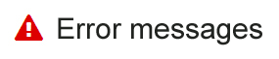
In the example of HTML code below, the <img /> tag simply enhances the title "Error messages" (which is explicit by nature):
<h2>
<img src="error.png" alt="" />
Error messages
</h2>

“Simple” informative <img />
A “simple” informative image is one that can be described by concise alternative text.
When a simple informative <img /> tag is used in the HTML code, populate its alt attribute with the information conveyed by the image.
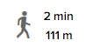
In the example of HTML code below, the <img /> tag refers to a walking time and distance:
<p>
<img src="walk.png" alt="By walking:" />
<span>2 min</span>
<span>111 m</span>
</p>
Warning
Do not start alternative text with alt="Image of […]".
This information is already provided by the assistive technology when it reads the <img /> tag.

“Complex” informative <img />
A “complex” informative image is one that requires a detailed description.
When a complex informative <img /> tag is included in the HTML code:
- Populate its alt attribute with information to make the image explicit.
- Propose a detailed description of the image directly below it.
- Lastly, indicate in the alt attribute where the detailed description can be found.
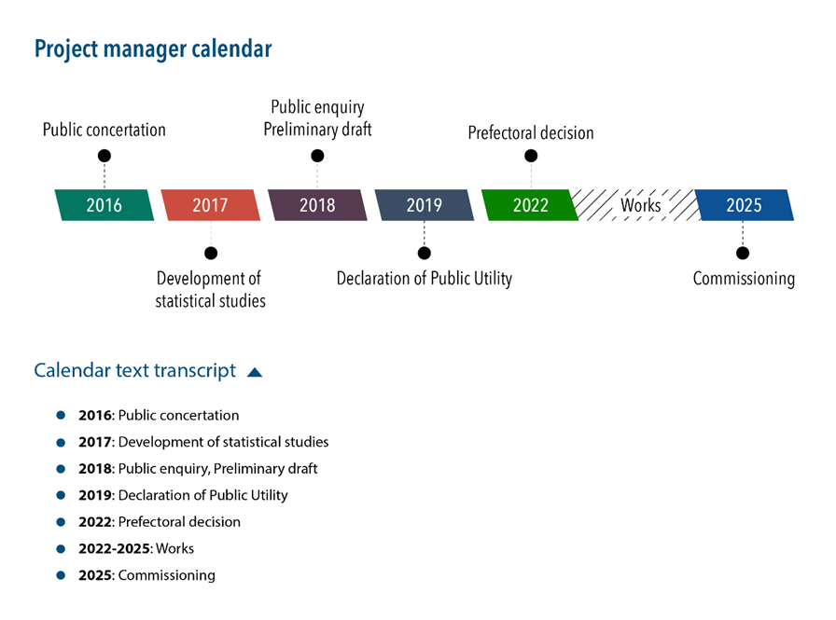
In this example, a show/hide button displays a detailed description
of the complex image.
In the following example of HTML code, the <img /> tag indicates both the function of the image and where to find its detailed description:
<h2>Project Manager calendar</h2>
<img src="female-reproductive-system.png" alt="Project manager calendar (detailed description below)" />
<button aria-expanded="true">Calendar text transcript</button>
<div>
<ol>
<li><strong>2016:</strong> Public concertation</li>
[…]
</ol>
</div>
Warning
Do not start alternative text with alt="Image of […]".
This information is already provided by the assistive technology when it reads the <img /> tag.

Unlabeled <img /> links or buttons
When an <img /> tag acting as link or button is included alone (without a label) in the HTML code, add the information needed to make it explicit into the alt attribute.
In the HTML code example below, the <img /> tag points to the home page:
<a href="/">
<img src="home.png" alt="Home" />
</a>
Warning
Do not start the alt text with alt="Link to […]" or alt="Button […]" when the <img> tag acts like a link or button.
This information is already provided to assistive technology by the <a> or <button> tag.

<input type="image" />
When <input type="image" /> is included in the HTML code, add the information needed to make the button explicit into its alt attribute.
In the HTML code example below, the <input type="image" … /> tag launches a search within the website:
<input type="image" src="magnifier.png" alt="Search site" … />
Warning
Do not start the alt attribute with alt="Button […]" when the <input type="image" … /> tag is acting as a link or button.
This information is already provided to the assistive technology by the <input type="image" … /> tag.

Managing alternative text on SVG (Scalable Vector Graphics)
4 cases:
- Decorative/ ambient <svg>.
- “Simple” informative <svg>.
- “Complex” informative <svg>.
- Unlabeled <svg> links or buttons.
Warning
In Internet Explorer, <svg> tags receive keyboard focus by default.
To optimize keyboard navigation in that browser, the focusable=”false” attribute must be added to each <svg> tag used to display an image.

Decorative/ambient <svg>
When an <svg> is simply decorative or ambient, add aria-hidden="true".
In the following HTML code, the <svg> simply enhances the label "Error Messages" (explicit by nature):
<h2>
<svg aria-hidden="true" focusable="false">[...]</svg>
Error Messages
</h2>
Warning
A purely decorative or ambient <svg> tag must not have any title, aria-label, aria-labelledby and/or aria-describedby attributes.
Likewise, it must not have a <title> and/or <desc> elements.

“Simple” informative <svg>
A “simple” informative <svg> is an informative image that can be described by concise alternative text.
When an informative <svg> image is included in the HTML code:
- Add a role="img" attribute to the <svg> tag.
- Add an aria-label attribute to the <svg> tag and populate the attribute with information to make the image explicit.
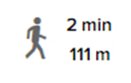
In the example of HTML code below, the <svg> indicates that the text applies to a walking time and distance:
<p>
<svg role="img" aria-label="By walking: " focusable="false">
[...]
</svg>
<span>2 min</span>
<span>111 m</span>
</p>
Warning
Do not start the <svg> alternative text with "Image […]".

“Complex” informative <svg>
A “complex” informative <svg> is an informative image that requires a detailed description.
When a “complex” informative <svg> is added to the HTML code:
- Add a role="img" attribute to the <svg> tag.
- Add an aria-label attribute to the <svg> tag and populate this attribute with information to make the image explicit.
- Propose a detailed description for the image directly below it.
- Finally, indicate in the aria-label attribute where this detailed description can be found.
In this example, a show/hide button displays a detailed description
of the complex image.
In the example of HTML code below, <svg> indicates the function of the image and where to find its detailed description:
<h2>Project Manager calendar</h2>
<svg role="img" aria-label="Projet Manager calendar (detailed description below)" focusable="false">
[...]
</svg>
<button aria-expanded="true">Calendar text transcript</button>
<div>
<ol>
<li><strong>2016:</strong> Public concertation</li>
[…]
</ol>
</div>
Warning
Do not start the <svg> alternative text with "Image […]".

<svg> links and buttons alone
When an <svg> image alone (without a label), acting as a link or a button, is included in the HTML code:
- Add a role="img" attribute to the <svg> tag.
- Add an aria-label attribute to the <svg> tag and populate this attribute with information to make the link or button explicit.
In the following example of HTML code, the <svg> points to the homepage of a website:
<a href="/">
<svg role="img" aria-label="Homepage" focusable="false">
[...]
</svg>
</a>
Warning
Do not start the <svg> alternative text of a link or a button with “Link to […]” or “Button to […]”.

Managing alternative text on Icon Fonts
Note
Whether the icon is decorative, informative, or acts as a link/button, the container tag should be given aria-hidden="true" to ensure that screen readers do not present this information to the user as they encounter it.
If possible, the tag serving the icon should be a <span> because it has no semantic value.
3 cases:
- Decorative/ambient icons.
- Informative icons.
- Link or button icons.

Decorative/ambient icons
When a decorative or ambient icon is included in the HTML code there is no need for an alternative.
In the following HTML code, the icon is simply a visual embellishment of the text "Error messages" (which is explicit by nature):
<h2>
<span class="icon error" aria-hidden="true"></span>
Error messages
</h2>

Informative icons
When an informative icon is included in the HTML code:
- Add a tag (e.g. <span>) immediately after the tag which contains the icon.
- Add information to this tag to make the icon explicit.
- Hide the content of the tag with CSS by placing it off-screen (outside the viewport) using the CSS "position: absolute;" property.
In the example of HTML code below, the icon refers to the time and distance to reach a destination by walking:
<p>
<span class="icon walking" aria-hidden="true"></span>
<span class="off-screen">By walking: </span>
<span>2 min</span>
<span>111 m</span>
</p>
.off-screen {
position: absolute;
left: -99999rem;
}

Links or buttons icons
When an unlabelled icon acting as a link or button is added to the HTML code:
- Add a <span> tag inside the <a> or <button> tag.
- Add text to the <span> tag to make the link or button explicit.
- Hide the content of the tag with CSS by placing it off-screen (outside the viewport) using the CSS "position: absolute;" property.
In the example of HTML code below, the icon is a link that points to the homepage:
<a href="/">
<span class="icon home" aria-hidden="true"></span>
<span class="off-screen">Home</span>
</a>
.off-screen {
position: absolute;
left: -99999rem;
}

Tag images that have captions with <figure role="figure"> and <figcaption>
Images that have captions must be tagged with <figure role="figure"> and <figcaption>.
The <figure role="figure"> tag must:
- Include the image and the legend, and the legend must be tagged with <figcaption>.
- Have an aria-label attribute that must have the same content as the <figcaption> tag.
Note
Ideally, the alternative text for the image (i.e. alt attribute for the <img /> tag) must contain a reference to the adjacent caption.

Example 1
Bolivian desert, picture by Audesou.
<figure role="figure" aria-label="Desert in Bolivia, photo by Audesou.">
<img src="…" alt="Three lamas in the Bolivian desert." />
<figcaption>
Desert in Bolivia, photo by Audesou.
</figcaption>
</figure>

Example 2
Photo 1: shot by Audesou in Bolivia.
<figure role="figure" aria-label="Photo 1 : shot by Audesou in Bolivia.">
<img src="…" alt="Three lamas in the desert. [photo 1]" />
<figcaption>
Photo 1: shot by Audesou in Bolivia.
</figcaption>
</figure>

Forms

Use the <label> tag with the for and id attributes to label form fields with a visible name
To label fields with a visible name:
- Use the <label> tag for each form name.
- Add the for attribute to each <label> tag and an id attribute on each form field.
- Populate the for and id attributes of each name/field pair with the same, unique value.
<label for="name">Your last name</label>
<input type="text" id="name" name="name" autocomplete="family-name" />
<label for="country">Your country</label>
<select id="country" name="country" autocomplete="country-name">
<option value="belgium">Belgium</option>
<option value="france">France</option>
[…]
</select>
Note
It is important to provide identical names for fields that have the same function.
For example, if there are several identification forms on the website, do not use "ID" on one, and "Login" on the other.

Use the title attribute to label form fields that don't have a visible label
To label form fields that don't have a visible label:
- Add title to the field.
- Populate the attribute by specifying the field’s function.
<input type="search" title="Your search" name="search" />
<input type="submit" value="Search" />
<select title="Filter news" name="filter">
<option>By Date</option>
<option>By Topic</option>
[…]
</select>
Warning
The placeholder attribute cannot be used as a label because it disappears during text entry.
It should only be used for secondary text entry aids that are not essential for understanding the field.
<input type="text" title="Your search" placeholder="Enter keywords" />

Use the autocomplete attribute to facilitate auto-fill
To facilitate auto-fill on fields referring to personal information:
- Add an autocomplete attribute to the field.
- Populate the autocomplete attribute according to the type of information expected.
<label for="first-name">Your first_name</label>
<input type="text" id="first-name" name="first-name" autocomplete="given-name" />
Note
The possible values for the autocomplete attribute are standardized.

Add help text directly to the <label> tags
Help text must be included directly in the <label> tags.
This particularly applies to:
- Indications such as “Required field”.
- Instructions on how to format the input such as MM/DD/YYYY.
- Information about the type and maximum size of files than can be sent.
- Etc.
<label for="date">
Date of Birth
<span>(MM/DD/YYYY)</span>
</label>
<input type="date" id="date" name="date" autocomplete="bday" />
<label for="number">
Your client number
<input type="text" id="number" name="number" aria-required="true" />
<span>i.e., BT-VZ</span>
</label>
Note
In some cases, because of a specific design layout for example, the help text cannot be included in the <label>.
In these cases:
- Add the id attribute to the tag containing the help text.
- Populate the id with a unique value.
- Add the aria-describedby attribute to the corresponding field.
- Populate aria-describedby with the id value included in the help text.
<label for="document">
Add a document to your case
</label>
<input type="file" id="document" name="document" aria
describedby="formats" />
<h2> Documents currently in your case</h2>
<ul>
<li>CV</li>
<li>Cover Letter</li>
</ul>
<p id="formats">Accepted formats: pdf or doc.</p>
Note that the aria-describedby attribute can reference several id values.
Warning
The placeholder attribute must not be used for entry aids that are essential for understanding the type of data to be entered.
It must be used only for secondary entry aids.
<input type="search" title="Your search" placeholder="Enter keywords" />

Add required or aria-required="true" to mandatory fields
Required fields must have a required or aria-required="true" attribute.
Note
In addition to this attribute, a distinctive sign must be included in the <label> tag.
<label for="email">Your email *</label>
<input type="email" id="email" name="email" autocomplete="email" required />
<input type="checkbox" id="conditions" aria-required="true" />
<label for="conditions">I accept the conditions of sale (required)</label>

Add error messages and correction suggestions directly to the <label> tag
When error messages and suggested corrections are placed next to the relevant form fields, they need to be added directly into the <label> tags.
Tip
In addition to the error message, good practice is to add aria-invalid="true" to the field.
<label for="name">
Your name *
<span>Please fill in your name</span>
</label>
<input type="text" id="name" name="name" autocomplete="family-name" aria-required="true" aria-invalid="true" />
<label for="email">
Your email *
<input type="email" id="email" name="email" autocomplete="email" aria-required="true" aria-invalid="true" />
<span>Please provide a valid email format (example@domain.com)</span>
</label>
Note
In some cases, because of a specific design layout for example, the error message cannot be directly included in the <label> tag.
In that case:
- Add an id attribute to the element that contains the error message.
- Give this id a unique value.
- Add aria-describedby to the corresponding input field.
- Add the id value of the error message to this aria-describedby attribute.
<label for="document">
Add a document to your file
</label>
<input type="file" id="document" name="document" aria-invalid="true" aria
describedby="formats error" />
<h2>Documents currently in your file</h2>
<ul>
<li>CV</li>
<li>Cover letter</li>
</ul>
<p id="error">File format incorrect.</p>
<p id="formats">Valid formats: pdf or doc.</p>
Note that aria-describedby can reference several id values.

Group and label related fields with <fieldset> and <legend>
When a form has multiple fields and some of them have the same label, use <fieldset> and <legend> to group them.
<fieldset>
<legend>Participant 1</legend>
<label for="firstName-1">First Name</label>
<input type="text" id="firstName-1" name="firstName-1" />
<label for="lastName-1">Last Name</label>
<input type="text" id="lastName-1" name="lastName-1" />
[…]
</fieldset>
<fieldset>
<legend>Participant 2</legend>
<label for="firstName-2">First Name</label>
<input type="text" id="firstName-2" name="firstName-2" />
<label for="lastName-2">Last Name</label>
<input type="text" id="lastName-2" name="lastName-2" />
[…]
</fieldset>
Warning
The <fieldset> and <legend> tags must systematically be used when several groups of fields have identical labels.
For example:
- A series of different questions on the same page which can all be answered “yes” or “no”.
- A list of participants at an event, featuring the First Names and Last Names of each participant.
If the form is too long, but none of the field groups have the same label, use the tags <h1> to <h6> to sort the fields groups.
Note
The use of <fieldset> and <legend> tags is particularly necessary when integrating radio button or checkbox lists.
For example:
<fieldset>
<legend>Sports played</legend>
<ul>
<li>
<input type="checkbox" id="basketball" />
<label for="basketball">Basketball</label></li>
<li>
<input type="checkbox" id="tennis" />
<label for="tennis">Tennis</label></li>
[…]
</ul>
</fieldset>

Lists

Tag unordered lists with <ul> and <li>
Use the <ul> and <li> tags to mark up lists of items which can appear in any order (menus, tabs, sharing buttons, site map, etc.).
If required, make sure that lists are properly nested:
<ul>
<li>First item of first level</li>
<li>
Second item of first level
<ul>
<li>First item of second level</li>
<li>Second item of second level</li>
</ul>
</li>
<li>Third item of first level</li>
</ul>

What are the advantages?
Structuring lists is essential for people using a screen reader (blind or visually impaired). When they come across a structured list, they are able to:
- Navigate from list to list within a page.
- Know from the start the number of elements in the list.
- Navigate more easily through the list:
  - Go directly to the end of the list if they are not interested in the content.
  - Easily return to the top of the list.

Tag ordered lists with <ol> and <li>
Use the <ol> and <li> tags to mark up lists of items that must appear in a specific order (list of steps in a procedure, ranking, etc.). In other words, when the information would not be understood if the items were presented in a different order.
If required, make sure that lists are properly nested:
<ol>
<li>First item of first level</li>
<li>
Second item of first level
<ul>
<li>First item of second level</li>
<li>Second item of second level</li>
</ul>
</li>
<li>Third item of first level</li>
</ol>

What are the advantages?
Structuring lists is essential for people using a screen reader (blind or visually impaired). When they come across a structured list, they are able to:
- Navigate from list to list within a page.
- Know from the start the number of elements in the list.
- Navigate more easily through the list:
  - Go directly to the end of the list if they are not interested in the content.
  - Easily return to the top of the list.

Mark up description lists with <dl>, <dt> and <dd>
Use <dl>, <dt> and <dd> tags to mark up description lists.
A description list is a series of key/value pairs that might be found, for example, in a product description, or in a glossary of terms.
Note
One keyword (<dt> tag) might have several values (<dd> tags).
Example with the description of an event:
<h2>Web Accessibility Conference</h2>
<dl>
<dt>Location</dt>
<dd>Paris</dd>
<dt>Dates</dt>
<dd>Saturday, September 7</dd>
<dd>Wednesday, October 14</dd>
<dt>Time</dt>
<dd>Starts at 10 a.m.</dd>
</dl>
Example with a glossary:
<dl>
<dt><dfn>ARIA</dfn></dt>
<dd>Accessible Rich Internet Application</dd>
[…]
<dt><dfn>WCAG</dfn></dt>
<dd>Web Content Accessibility Guidelines</dd>
[…]
</dl>

What are the advantages?
Structuring lists is essential for people using a screen reader (blind or visually impaired). When they come across a structured list, they are able to:
- Navigate from list to list within a page.
- Know from the start the number of elements in the list.
- Navigate more easily through the list:
  - Go directly to the end of the list if they are not interested in the content.
  - Easily return to the top of the list.

Tables

Use <caption> to tag data table captions
When a data table is introduced by a caption, it must be tagged using the <caption> tag.
Note
The caption must be precise and concise.
<table>
<caption>Average monthly temperatures of the 3 largest cities in Canada.</caption>
[…]
</table>

Mark up the row and column header cells with <th>
In all data tables, mark up each column and row header cell with the <th> tag.
When a cell is essential to understand the data provided in the table, it must be marked up with <th>.
<table>
<caption>Average monthly temperatures of the 3 largest cities in Canada.</caption>
<tr>
<td>&nbsp;</td>
<th>Toronto</th>
<th>Montreal</th>
<th>Vancouver</th>
</tr>
<tr>
<th>June</th>
<td>22°C</td>
<td>28°C</td>
<td>26°C</td>
</tr>
<tr>
<th>July</th>
<td>24°C</td>
<td>30°C</td>
<td>28°C</td>
</tr>
</table>
Average monthly temperatures of the 3 largest cities in Canada.
 | Toronto | Montreal | Vancouver
June | 22°C | 28°C | 26°C
July | 24°C | 30°C | 28°C

In simple data tables use the scope attribute to associate data cells with their corresponding headers
A data table is simple when each header cell applies to all the cells in the row or column.
To associate headers with their corresponding data in this type of table, add the scope attribute to the <th> tags. The value of the attribute depends on whether the header cell concerns:
- An entire column: scope="col".
- An entire row: scope="row".
<table>
<caption>Average monthly temperatures of the 3 largest cities in Canada.</caption>
<tr>
<td>&nbsp;</td>
<th scope="col">Toronto</th>
<th scope="col">Montreal</th>
<th scope="col">Vancouver</th>
</tr>
<tr>
<th scope="row">June</th>
<td>22°C</td>
<td>28°C</td>
<td>26°C</td>
</tr>
<tr>
<th scope="row">July</th>
<td>24°C</td>
<td>30°C</td>
<td>28°C</td>
</tr>
</table>
Average monthly temperatures of the 3 largest cities in France.
 | Paris | Marseille | Lyon
June | 22°C | 28°C | 26°C
July | 24°C | 30°C | 28°C

Add role="presentation" to each layout <table>
Mark up layout tables by including role="presentation" in the <table> tag.
<table role="presentation">[…]</table>

Using CSS

Use CSS to lay out text
Texts must not be integrated as images but as texts in HTML format stylized with CSS.
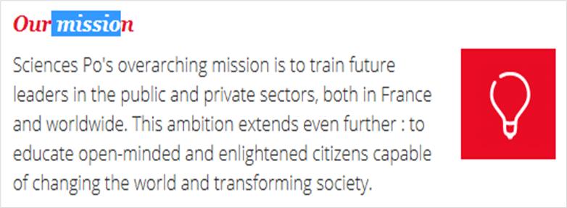
Example of a specific font added in text format

Ensure that content can be read when images are turned off
When images are turned off, the page content must remain visible and readable. No information must be lost and there must be sufficient contrast between the foreground and background.
In other words, all the content must be visible and readable:
- Even when CSS images are turned off for the page.
- Even when HTML images are replaced with their alt attributes.
Note
Whenever text is placed over a background image, make sure to provide an alternative background color that will ensure text readability in the absence of the background image.
background: black url(../images/dark-background.png) repeat-x;
This replacement color can be inherited from a parent.
Warning
Special attention must be paid to the readability of alternative text for images embedded in the HTML code when images are turned off.

Ensure that content is understandable when CSS is disabled
Ensure that the information remains available and understandable even when CSS is disabled, especially when colors, sizes, shapes or positions are information carriers.
Also, make sure not to generate informative content using only CSS.

Examples

Position of the current selection in the menu (Example 1)
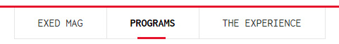
In this example, "Programs" has bold text and a red border indicating it is currently selected.
In the solution presented below, a <strong> tag is added to ensure that the information is not lost without CSS.
<a href="…" aria-current="true">
<strong>Programs</strong>
</a>

Position of the current selection in the menu (Example 2)
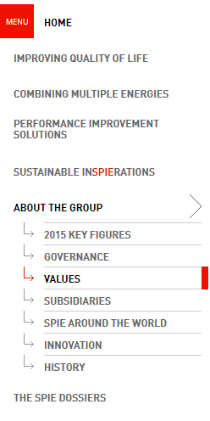
In this example, a different colored arrow and an additional border indicate that the link "Values" is the current page.
In this case, an efficient way of conveying that it is the current page without using CSS is to remove the surrounding <a> tag.
<ul>
<li><a href="…">2015 key figures</a></li>
<li><a href="…">Governance</a></li>
<li aria-current="page">Values</li>
<li><a href="…">Subsidiaries</a></li>
<li><a href="…">SPIE around the world</a></li>
<li><a href="…">Innovation</a></li>
<li><a href="…">History</a></li>
</ul>

CSS Generated Content (Example 3)
When informative content is necessary to understand the content, it must not be generated by CSS.
a[href*=".pdf"]::after {
content: ' (PDF)';
}
In this example, information about the PDF format of the downloadable files is added with CSS. This is incorrect.
label.required::after {
content: ' *';
}

input[aria-required=true]::before {
content: '* ';
}
In these examples, the asterisk flagging up the mandatory fields of a form is added using CSS, which is also incorrect.

Zoom and font sizes

Use only relative font sizes (rem, em, %, etc.)
To set the font size, use only relative units in CSS font-size such as rem, em, % or keywords (x-small, small, etc.).
Do not use absolute units such as pt, cm, etc.
Warning
Although the pixel (px) can be used to define font size, it can prevent font size increase in some cases.
We strongly advise against using it.
Note
This recommendation does not apply to CSS print (media type print).

Ensure content readability even when font size is doubled
Guarantee content readability even when font is twice the default size.
Across the entire font size increase range, content and functionalities must not overlap or disappear.
To ensure this rule is respected:
- Use only relative units (rem, em, %, etc.) to manage spaces (CSS properties margin and padding).
- Do not use units (px, pt, em, %, etc.) with the CSS line-height property.
- Do not define a fixed height (CSS height property) on elements likely to contain text, particularly form fields.
- Be careful when using absolute positioning (CSS declaration: position: absolute;). Although this type of positioning is compatible with accessibility, it can cause content overlap in some cases.

Keyboard Navigation

Ensure the proper functioning of the interface using either the mouse or keyboard
All interactions must be possible using either the mouse or the keyboard.
In other words, whenever the mouse can be used to interact with a component, the same must also be true for the keyboard.
This is the case for example when displaying/hiding:
- A sub-menu.
- A modal window.
- A customized tooltip.
Warning
Whether keyboard navigation is forwards or backwards, the page must not contain any keyboard traps.
I.e. the keyboard focus must never:
- Remain blocked on an element without any way out.
- Loop in zone on the page without any way out.
Note
Make sure that mouse and keyboard interactions also work on touch screens (and vice versa).

Ensure that the tab order follows the logical reading order
The tab order must logically follow the visual order of the page.
In other words, if an interactive element follows another interactive element in the visual presentation of the page, the focus must also move from the first to the second element in the same order.
Warning
Do not use positive values (value above 0) on the tabindex attribute because it can disrupt the natural tab order of the page.
Note
In some rich interface components such as tabbed interfaces, the arrow keys rather than the Tab key are used to navigate from one interactive element to another.

Ensure that keyboard focus is visible
In order to ensure that users navigating using the keyboard know where they are on the page, each interactive element (links, buttons, form fields, etc.) must stand out visually when it receives focus.
Note
Ensure that this focus indicator has sufficient contrast.
Tip
Good accessibility practice is to systematically back up each:hover rule with a :focus rule in CSS.
For example:
main a:hover,
main a:focus {
text-decoration: none;
}

Introduce “skip links”
A "Skip to content" must be placed on each page to help keyboard users navigate the page.
This should be the first interactive element in the HTML code.
This internal link will take the user directly to the main content.
<body>
<a class="skiplink" href="#content">Skip to content</a>
[…]
<main role="main">
<a id="content" tabindex="-1"></a>
[…]
</main>
[…]
</body>
Note
The link may be hidden by default. However, it must become visible when it receives keyboard focus.
Therefore, the "skip to content" link should never be hidden using CSS properties display: none; and/or visibility: hidden; which would make it completely unusable with keyboard navigation.
A better approach would be to use the code below:
a.skiplink {
display: inline-block;
color: #555;
background: #fff;
padding: .5em;
position: absolute;
left: -99999rem;
z-index: 100;
}
a.skiplink:focus {
left: 0;
}
Tip
In some situations, it takes a lot of tabbing to reach the main and secondary menus and/or search engine from the top of the page.
In these cases, add "Skip to" links, as in the following example:
<ul id="skiplink">
<li>
<a href="#content">Skip to content</a>
</li>
<li>
<a href="#nav">Skip to navigation</a>
</li>
<li>
<a href="#search">Skip to search</a>
</li>
</ul>

Iframes

Populate the title attribute on each <iframe
Whenever an <iframe> tag is included in the page, it is also necessary to add a title attribute.
The attribute value must introduce the content of the <iframe> tag clearly and concisely.
For example, in the case of an <iframe> loading a video player on the page:
<iframe src="https://www.youtube.com/embed/y525BrxyvhA" title="Vidéo YouTube : L'accessibilité numérique à toutes les étapes d'un projet">
[…]
</iframe>

Additional Guidelines
Some guidelines found in accessibility reference documents were not included in this manual as they are considered as rarely applicable.
It is however necessary to respect these additional rules to ensure compliance with RGAA 4 and WCAG 2.1.
They are listed below:
- Make sure the information is understandable, even without color
- Ensure content readability even when text spacing properties are customized
- Incorporate the summary of each complex data table in the <caption> tag
- Provide alternative text for each informative <canvas>, <embed> and <object> tag
- Provide alternative text for each <canvas>, <embed> and <object> tag used as a link or button.
- Hide each decorative or ambient <canvas>, <embed> and <object> tag on assistive technologies
- Do not initiate an action while the trigger is in the "pressed" state
- Anticipate the interface behavior
- Group related options in <select> boxes with <optgroup>
- Add the title attribute to describe each <frame>
- Use the dir attribute to indicate a change in reading direction.

Tag block quotations using <blockquote>
Whenever, a block quotation is to be included in the HTML page, enclose it in a <blockquote> tag.
Note
Any isolated quote that is not directly incorporated in the surrounding text flow, is considered as a block quotation.

Tag online quotations using <q>
Whenever a quotation is integrated in a text, enclose it in the <q> tag.

Write the HTML code in a logical reading order
The writing order of the tags in the flow of the HTML code must follow the reading order of the page.
In other words, when one tag precedes another in the visual flow of the page, it must also immediately precede that element in the HTML code.
Tip
To test this rule, turn off the CSS and check that the resulting page order matches the page when CSS is active.
Warning
If some content is hidden by default, make sure that it is properly positioned in the HTML flow when styles are disabled.

Indicate in the alternative text for visual CAPTCHA where to find the non-visual version
Whenever a visual CAPTCHA is used, indicate in the alternative text the information needed to:
- Identify it as a security system.
- Find the non-visual version of the CAPTCHA.
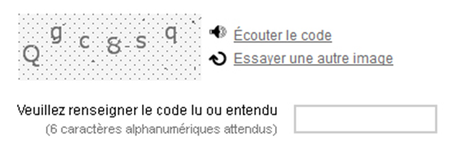
It is often an audio version, so in this case opt for:
<img src="captcha.png" alt="Spam protection system: If you can’t use it, use the audio version available below." />
Note
To correctly enter the alternative text in compliance with the CAPTCHA integration technique, refer to sheets on the topic Images and icons.

Do not use tags or attributes specific to data tables in layout table
A layout table must not have any tags or attributes specific to data tables.
This means that:
- The tags <caption>, <colgroup>, <tfoot>, <th> and <thead> must not be used in layout tables.
- The attributes axis, headers and scope must not be used in layout tables.

Plan alternative text for each type of multimedia content (<video>, <audio>, <object>, <embed>, etc.)
Plan alternative text for each type of multimedia content embedded in the page using the tags <video>, <audio>, <object>, <embed>, for example.
This alternative text will provide the same level of information to people who cannot access the multimedia content (no plugin, old browser, etc.).
It can take the form of HTML content for example.
Tip
When a video is displayed on a page, its transcription can be considered as an alternative.
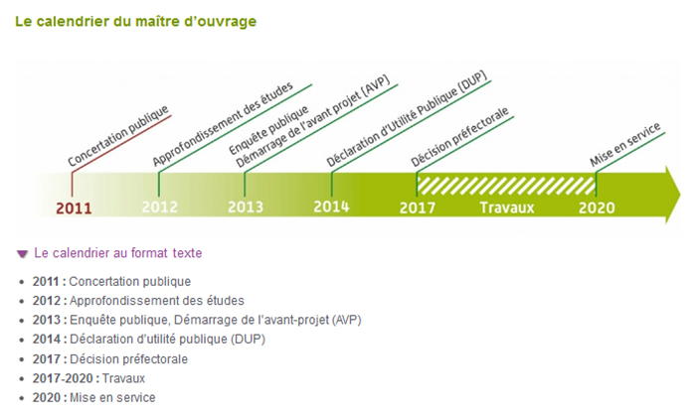
In this example, the calendar is a video carrying information, and a link
“The calendar in text format” leads to alternative text in HTML format.

Populate the alt attribute of each mapped image and its <area /> tags
When a mapped image is integrated in the HTML code:
- An attribute must be added to the <img /> tag and to each <area /> tag.
- The alt attribute of the <img /> tag must announce the function of the mapped image.
- The alt attribute of each <area /> tag must express the destination of the link.
For example, in the case of a map of France where each department is clickable and leads to an information sheet about the department:
<img src="…" alt="Map of France" usemap="#map-France" />
<map name="map-France">
<area shape="poly" coords="…" href="…" alt="Ain" />
<area shape="poly" coords="…" href="…" alt="Aisne" />
<area shape="poly" coords="…" href="…" alt="Allier" />
[…]
</map>

In complex tables, use the headers and id attributes to associate header cells with their corresponding data cells
A data table is complex when the header cells do not apply to all the cells in the row or column.
To associate headers with their corresponding data cells in this type of table, add the id attribute to all <th> cells and the headers attribute to all the <td> cells.
The next step is to populate the headers attributes with the values found in the corresponding header cells. If several headers are associated with a data cell, they are separated by a space (space delimited) in the corresponding headers attribute.
<table>
<caption>Sales revenue comparison of Davis and Davison companies in the UK and in the rest of the world.</caption>
<tr>
<th id="header-1">In millions of pounds sterling</th>
<th id="header-2">In the UK</th>
<th id="header-3">Rest of the World</th>
</tr>
<tr>
<th id="header-4">Davis</th>
<td headers="header-4 header-2 header-1">
50.7
</td>
<td headers="header-4 header-3 header-1">
139.3
</td>
</tr>
<tr>
<th id="header-5">Davison</th>
<td headers="header-5 header-2 header-1">
27.1
</td>
<td headers="header-5 header-3 header-1">
476.0
</td>
</tr>
</table>
Comparison of sales revenue between the companies Dupond and Dupont
in France and the rest of the world.
In millions of euros | In France | Rest of the World
Dupond | 50.7 | 139.3
Dupont | 27.1 | 476.0
Warning
The headers attribute must not be used in combination with the scope attribute.
Note
Good practice is to organize the id values of the header cells according to the logical visual order of the table.
A screen reader (using voice or braille) will announce the headers in this order.

Ensure that the HTML flow is consistent from one page to the next
The order of the main content blocks in the HTML flow must remain consistent from one page to the next.
For example, if the secondary menu is placed after the main content, it is important to keep this order on all pages of the website.

Make sure layout tables follow the right reading order
When a screen reader (voice or braille) translates a layout table, the content is read in a linear way i.e. cell by cell, from left to right, row after row.
So the reading order should remain consistent on each layout table.
For instance, if the source code below is used, the reading order will be:
- First name.
- Last name.
- Age.
- “First name” field.
- “Last name” field.
- “Age” field.
<table role="presentation">
<tr>
<td><label for="first-name">First name</label></td>
<td><label for="last-name">Last name</label></td>
<td><label for="age">Age</label></td>
</tr>
<tr>
<td><input type="text" name="first-name" id="first-name" /></td>
<td><input type="text" name="last-name" id="last-name" /></td>
<td><input type="text" name="age" id="age" /></td>
</tr>
</table>
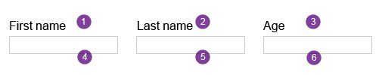
To follow a coherent reading order while keeping the layout table, try this instead:
<table role="presentation">
<tr>
<td>
<label for="first-name">First name</label>
<input type="text" name="first-name" id="first-name" />
</td>
<td>
<label for="last-name">Last name</label>
<input type="text" name="last-name" id="last-name" />
</td>
<td>
<label for="age">Age</label>
<input type="text" name="age" id="age" />
</td>
</tr>
</table>
Warning
To ensure optimal screen reader compatibility and guarantee that the right reading order is followed, it is strongly recommended to limit the use of nested layout tables

Additional recommendations
In addition to the mandatory rules detailed in the previous chapters of this manual, taking into account the additional recommendations below is beneficial for people with disabilities.
We therefore strongly recommend that you apply them.

Tag abbreviations with <abbr>

Combine adjacent links pointing to the same page
When several links pointing to the same page are grouped together, they should be combined in a single tag <a>.
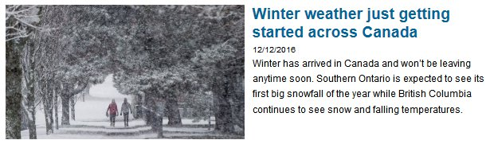
Here is an example of coding for an image, a title, a date and an introduction serving as a link to the details of a news item that we do not recommend:
<a href="…">
<img src="people-in-the-snow.jpg" alt=" Winter weather just getting started across Canada" />
</a>
<h2><a href="…">Winter weather just getting started across Canada</a></h2>
<p class="date">
<a href="…">12/12/2016</a>
</p>
<p class="intro">
<a href="…"> Winter has arrived in Canada and won’t be leaving anytime soon. Southern Ontario is expected to see its first big snowfall of the year while British Columbia continues to see snow and falling temperatures.</a>
</p>
And here is a more accessible coding:
<a href="…">
<img src="people-in-the-snow.jpg" alt="" />
<h2>Winter weather just getting started across Canada</h2>
<p class="date">12/12/2016</p>
<p class="intro">Winter has arrived in Canada and won’t be leaving anytime soon. Southern Ontario is expected to see its first big snowfall of the year while British Columbia continues to see snow and falling temperatures.</p>
</a>
Note
This recommendation also applies to <button> tags.
Here is an example of coding of a grouped icon and text serving as an Add bookmark button that we do not recommend:
<button>
<img src="favorites.png" alt=" Add to favorites" />
</button>
<button>Add to favorites</button>
And here is a more accessible coding:
<button>
<img src=" favorites.png" alt="" />
Add to favorites
</button>

In forms with multiple steps, identify the current step using aria-current="step"
In the navigation menu of a form with multiple steps, the current step should be identified by means of aria-current="step".
<nav aria-label="Steps of your order">
<ol>
<li><a href="…">Personal information</a></li>
<li aria-current="step"><em>Payment</em></li>
<li>Preview</li>
</ol>
</nav>
Note
When forms have multiple steps, it should also be possible for the user to return to a previous step by means of a link, for example.

Identify the current position in navigation systems with aria-current
In all navigation systems (menus, breadcrumb trails, pagination systems, etc.), the current position is to be identified by aria-current="page".
Likewise, any parent sections and sub-sections are to be identified by aria-current="true", only in menus (and not in breadcrumb trails) by.

Example in a menu
In the example below of code for a navigation menu, the parent section “Upcoming events” is identified by aria-current="true" included in the <a> tag and the current page “Education” is identified by aria-current="page" included in the <li> tag.
<nav role="navigation" aria-label="Main menu">
<ul>
<li><a href="…">Home</a></li>
<li><a href="…" aria-current="true">Upcoming events</a>
<ul>
<li><a href="…">Culture</a></li>
<li aria-current="page">Education</li>
<li><a href="…">Sports</a></li>
</ul>
</li>
<li><a href="…">News</a></li>
<li><a href="…">Contact</a></li>
</ul>
</nav>

Example in a pagination system
In the code example below for a pagination system, the current page “2” is identified by aria-current="page" included in the <li> tag.
<nav aria-label="Pagination">
<ul>
[…]
<li><a href="…" aria-label="Page 1">1</a></li>
<li aria-current="page">2</li>
<li><a href="…" aria-label="Page 3">3</a></li>
[…]
</ul>
</nav>

Example in a breadcrumb trail
In the example below of code for a breadcrumb trail, the current page “Editorial manual” is identified by aria-current="page" included in the <li> tag.
<nav aria-labelledby="intro-pagination">
<p id="intro-pagination">You are here:</p>
<ul>
<li><a href="…">Home</a></li>
<li><a href="…">AcceDe Web guidelines</a></li>
<li aria-current="page">Editorial manual</li>
</ul>
</nav>

Add file format and size to all Download links and buttons
Whenever a link or button points to a download file, the following information should be added to the label:
- Document name.
- Document format.
- Document size.
<a href="Toronto bus service.pdf">
Download the map of Toronto bus routes (PDF - 2 MB)
</a>
Note
If an icon is used to indicate the file format, refer to “Images and Icons“, to implement it in an accessible way.
Tip
In situations where the size of the downloadable file cannot be known in advance (i.e. generation on the fly), good accessibility practice is to give an approximate or maximum size.
For example:
<a href="invoice.pdf">
Download your March invoice (PDF – Approx. 1.5MB)
</a>

Update the page <title> when an error or confirmation message is displayed
Whenever a form returns an error or confirmation message, it is advisable to update the <title>.
In the case of a confirmation message:
<title>Confirmation - Contact | [site name]</title>
If there is an error:
<title>Error - Contact | [site name]</title>
Tip
It is also recommended to have this information appear first in the <title> tag.
Note
In some situations, the title does not need to be updated because the title displayed after submission is already obvious.
For example
- A login form which goes directly to a profile page.
- A button which says “Next step” as part of a multi page form.
- A contact page that sends a preview page.

Do not disable the zoom with the user-scalable property
It is important to be able to zoom in or out of a page. For this purpose, the following declarations must not be used:
<meta content="width=device-width;initial-scale=1.0; maximum-scale=1.0; user-scalable=1;" name="viewport" />
<meta name="viewport" content="user-scalable=no" />

Do not use CSS to display images that carry information
CSS should not be used to display images that carry information.
In other words, images with information should be hard-coded in the HTML (i.e. via the <img /> or svg tag).
Note
Image sprites (images loaded in the background via CSS) are not appropriate for images that carry information.
Tip
Images are considered as information carriers if some of the page content or functions were missing without them. These images include:
- Logos.
- Text images.
- Images used as links or buttons.
- Etc.
Warning
In particular, we strongly advise against the technique of placing text off-screen and replacing it with a background image.
When the images are not uploaded, the information may be lost.
<a href="/" id="logo">[My logo text]</a>
#logo {
display: block;
width: 300px;
height: 100px;
text‐indent: ‐99999rem;
background: url('images/logo.png');
}
Pure HTML should be used instead.

Logically organize the items of dropdown lists
When dropdown lists are used, the options listed should be organized logically.
The logical order depends on the context. Examples include:
- Alphabetical order (e.g. a list of languages).
- Numbered order (e.g. a list of French departments).
- Practical order ("France" first in form to sign up for a French government agency).
Tip
Another good accessibility practice is to avoid prefixing the content of the <option> tag with decorative characters (dashes, stars, spaces, etc.).
This will give the user direct access to a desired value or group of values by simply pressing a key on the keyboard (pressing the "S" key to reach the country "Spain", for example).
<select>
<option>--Belgium</option>
<option>--France</option>
<option>--Germany</option>
<option>--Italy</option>
<option>--Spain</option>
</select>
Should be replaced by:
<select>
<option>Belgium</option>
<option>France</option>
<option>Germany</option>
<option>Italy</option>
<option>Spain</option>
</select>

Send a notification when a new window is opened
When a link or button opens a new window in the browser, it is advisable to add information such as “new tab”.
Either in the aria-label attribute:
<a href="gtc.html" target="_blank" aria-label="General Terms and Conditions (new tab)">
General Terms and Conditions
</a>
Or in the alternative text of an icon/image as follows:
- Icon Fonts.
- Of an svg (vector graphic).
- Of a tag <img />.
Note
Use of the title attribute also complies with accessibility requirements:
<a href="gtc.html" target="_blank" title="General Terms and Conditions (new tab)">
General Terms and Conditions
</a>

Use only relative sizes (rem, em, %, etc.) for media query breakpoints
To define media query breakpoints, it is advisable to use relative units only (such as rem, em or %) for the CSS @media rule
@media (max-width: 25rem) {
nav li.tile {
width: 33%;
}
}
rather than absolute units such as px, pt, cm, etc.
Note
This recommendation also applies for media queries directly integrated in the <link /> tag:
<link rel="stylesheet" href="/css/extra-small.css" media="all and (max-width: 25rem)" />

Make sure that hidden content is translated
For websites in multiple languages or when using scripts developed in a foreign language, make sure to translate into the website’s current language all the hidden content in:
- alt attributes of images.
- aria-label attributes.
- title attributes.
- Tags for content not visible on screen.
(via a CSS class “.sr-only”, for example)

