
Accessibility guidelines for editors
(template)
Date | Version | Author | Status / comments
Nov 3rd, 2018 | 3.0 | Atalan
In partnership with:
Air Liquide – Atos – BNP Paribas – Capgemini – EDF – Generali – SFR – SNCF – Société Générale – SPIE
Observers:
AbilityNet – Agence Entreprises & Handicap – AnySurfer (Belgium) – Association des Paralysés de France (APF) – Association Valentin Haüy (AVH) – CIGREF – Design For All Foundation (Spain) – ESSEC – Handirect – Hanploi – Sciences Po – Télécom ParisTech

Acknowledgements
Special thanks to our AcceDe Web partners for their input and commitment:

Thanks to their support, participation in the working groups, proofreading of documents, and testing of manuals, the partner companies have provided valuable input to the Accede Web project. This has made it possible to create manuals that successfully meet the needs of the different stakeholders of a web project. These companies are also contributing to making the web more accessible by authorizing the free distribution of this content.
We would also like to thank the following observers of the AcceDe Web project whose actions raise awareness of the AcceDe Web manuals and aid their distribution: AbilityNet (UK), Agence Entreprises & Handicap, AnySurfer (Belgium), Association des Paralysés de France, Association Valentin Haüys, CIGREF, Design for All foundation (Spain), ESSEC, Handirect, Hanploi, Sciences Po and Télécom ParisTech.
We thank all the members of the review committees for the quality and relevance of their comments:
- English version: Robin Christopherson (UK - AbilityNet), Ramon Corominas (Spain - Technosite), Deborah Edwards-Onoro (USA - Lireo Design), Thomas Frandzen (Denmark - Agency for Digitisation, Ministry of Finance), Char James-Tanny, (USA - a11yBos), Matt May (USA – Adobe), Sophie Schuermans (Belgium – Anysurfer), Jared Smith (USA - WebAIM), Christophe Strobbe (Germany), Gijs Veyfeyken (Belgium – Anysurfer)
- French version: Benjamin Ach (accessibility expert), Vincent Aniort (APF), Jean-Baptiste Audras (University of Grenoble), Claire Bizingre (accessibility consultant), Victor Brito (accessibility consultant), Anna Castilla (Provaltis), Ève Demazière (Sciences Po), Nicolas Fortin (French Ministry of Media and Culture), Marc-Étienne Vargenau (Alcatel-Lucent) and Éric Vidal (Fédération des aveugles de France), as well as all the teams of our partner companies.
Finally, we would like to thank Laurent Bracquart and Johan Ramon, Christophe Pineau and Marion Santelli of Atalan for their dedication and commitment to this initiative.
Sébastien Delorme, Sylvie Goldfain,
Atalan
Table of contents
Introduction 4
Context and objectives 4
Who should read this user guide, and how should it be used? 4
Contact 5
License agreement 5
1. Formatting accessible content 6
1.1. Do not justify text 6
1.2. Avoid multiple line breaks 6
2. Use a consistent hierarchy of headings 8
3. Write accessible links 9
3.1. Write unique and explicit text links 9
3.2. For each downloading file, specify the name, type and size (and language if different from the language of the page) 9
3.3. Identify links that open up a new window or tab 10
3.4. Using link titles as a last resort 11
4. Make images accessible 13
4.1. Decorative/illustrative images: do not write an alternative text 14
4.2. Informative images: write an alternative text 14
4.3. Link-images: write an alternative text that describes the purpose of the link 15
4.4. Complex informative images: write a short alternative text as well as a detailed description 16
5. Use bulleted and numbered lists correctly 17
6. Write content in an accessible way 18
6.1. Keep accents on capital letters 18
6.2. Expand the first occurrence of acronyms or abbreviations to their full meaning within content 19
6.3. Identify inline quotes and block quotes 19
6.4. Identify language changes 20
6.5. Do not refer to an item by indicating its color, shape, or position alone 22
7. Use colors and contrast correctly 23
7.1. Ensure that the contrast between text or images and background color is sufficient 23
7.2. Do not convey information by colour alone 23
8. Use rich content and multimedia correctly 26
8.1. Associate a detailed description with rich content (charts, maps, Flash animations) 26
8.2. Ensure that moving content can be paused 26
8.3. Ensure that videos have a transcription, closed captions (and audio description if applicable) 27

Introduction

Context and objectives
This document is a template with recommendations that can be customized for each project and used to write an accessibility manual specifically designed for content editors, with all the instructions they need on how to make online content accessible.
This document lists the good practices to be applied by content editors to make sure their web content is accessible (links, images, text, etc.). It also explains how to customize the instructions and adapt them to the content management system (CMS) used.
This manual is part of a set of four complementary manuals that can be downloaded from the AcceDe Web website:
- Accessibility guidelines for graphic design.
- Accessibility guidelines for HTML and CSS.
- Accessibility guidelines for rich interfaces and JavaScript.
- Accessibility guidelines for editors (template).

Who should read this user guide, and how should it be used?
Warning
This document should not be given to content managers in its current state.
It is a template that can be modified or completed in order to provide editorial accessibility guidelines for each project or publishing tool used. Content from this template can also be added to the manual already used for the publishing software.
The template highlights the items that can be modified depending on the publishing software used. Some of the editorial recommendations can also be removed, if the publishing tool does not allow the user to implement them.
When the template content has been customized, it can be distributed to:
- Content editors.
- Organizers of websites, intranets or online communities.
- Webmasters.
- Etc.

Contact
Please send any comments about this document to Atalan, the coordinator of the AcceDe Web project, at the following email address: accede@atalan.ca.

License agreement
This document is subject to the terms of the Creative Commons BY 3.0 license.
You are free to:
- Copy, distribute and communicate the work to the public.
- Change this work.
Under the following conditions:
- Mention of the authorship if the document is modified:
  - You must include the Atalan and AcceDe Web logos and references, indicate that the document has been modified, and add a link to the original work at http://www.accede-web.com/en.
  - You must not in any circumstances cite the name of the original author in a way that suggests that he or she endorses you or supports your use of the work without its express agreement.
  - You must not in any circumstances cite the name of partner companies (Air Liquide, Atos, BNP Paribas, Capgemini, EDF, Generali, SFR, SNCF, Société Générale and SPIE), or the organizations which have supported this initiative (AbilityNet, Agence Entreprises & Handicap, AnySurfer, Association des Paralysés de France (APF), CIGREF, Design For All Foundation, ESSEC, Handirect, Hanploi, Sciences Po and Télécom ParisTech) without their express agreement.
The Atalan and AcceDe Web logos and trademarks are registered and are the exclusive property of Atalan. The logos and trademarks of partner companies are the exclusive property of Air Liquide, Atos, BNP Paribas, Capgemini, EDF, Generali, SFR, SNCF, Société Générale and SPIE.

Formatting accessible content

Do not justify text
Text justification is poorly rendered on the web, and can sometimes make it difficult for users to read the text. It is preferable to use left-aligned or right-aligned text.
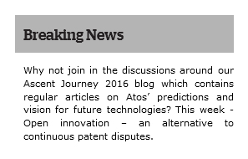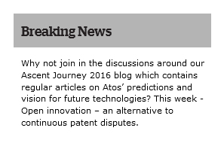
In this first example, the justified text leads to irregular and large gaps between words,
which may make it difficult to read the text.

To be customized
A simple way of ensuring that there is no justified text is to deactivate this feature directly in the publishing tool.
If you do so, you can delete this recommendation from the document supplied to content editors.

Avoid multiple line breaks
As a general rule, multiple line breaks used to add space between two content items should be avoided. They are likely to disturb screen reader users.
It is preferable to use the features provided by the publishing software for managing spacing between items.
To be customized
Delete the previous paragraph if the publishing software does not provide these features.
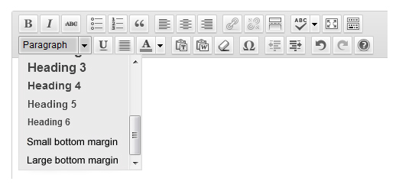
Use the styles “Small margin bottom” and “Large margin bottom” to add margins
of different sizes to the bottom of items.
To be customized
In the section above, specify the features used by the publishing software for applying margins to elements, or delete this box if the publication software does not have these features.

Use a consistent hierarchy of headings
In a web page, content should be structured by means of headings 1 to 6. The choice of heading level is made according to its position in the hierarchy.
Tip
A simple technique for correctly structuring headings is to imagine how the “table of contents” will look from the current heading hierarchy. Is the table of contents consistent? us it easily understood?
The publishing software will automatically consider the top-level content as a Heading 1. The headings used in the body of the content will therefore need to start from Heading 2 (going up to Heading 6, if necessary).
To be customized
Change the previous paragraph to specify the heading level that contributors need to start with.
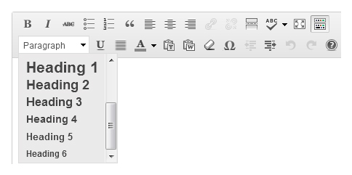
Use the “Heading” drop-down menu to apply the right heading level (1 to 6) to the selected text.
To be customized
In the section above, specify the feature used in the publishing software to assign headings 1 to 6.
It is important to be consistent when using headings and sub-headings, and not skip a heading level in the hierarchy (i.e. go straight from a Heading 2 to a Heading 5, for example).
It is also important to ensure that the entire content creation team uses the same heading structure, to keep over all site navigation consistent
Warning
Headings must only be used to identify headings.
It is important not to use them just to enlarge text, for example.

Write accessible links
The method for writing accessible links varies according to the type of link.

Write unique and explicit text links
The text link is the text of the hyperlink displayed on the screen.
As far as possible, the text of a link should describe exactly where it goes in unambiguous terms. Use clear and explicit link texts that can be understood when read without the text that surrounds them.
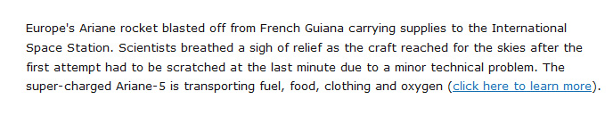
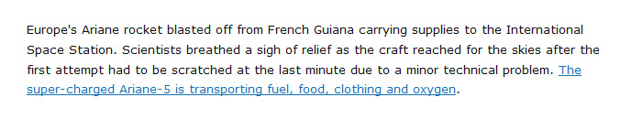
Links such as “Click here”, “More information” or “Read on” are therefore to be avoided for more informative links such as “Mr Cameron’s statement (read on)”, “Find out more about the Wiltshire contract”, or “More about our welcome offer”.

For each downloading file, specify the name, type and size (and language if different from the language of the page)
When the content includes links for downloading files, the following information should be included in the link text:
- Document title.
- Document type.
- Size of document.
- Document language (if it is different from the main page language).
Usually, the publishing software automatically adds the size and type of files that are published. For internal documents, simply check that this information is displayed once the content is published.
To be customized
Delete the previous paragraph if the publishing software automatically adds the document format and size to the link text when files are published.
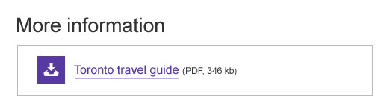
For example, if the link “Toronto travel guide” leads to a PDF file weighing 346 kb, the link text can be optimized to show “Toronto travel guide (PDF, 346 kb)”.
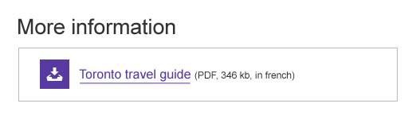
If the link “Toronto travel guide" leads to a PDF file in French, weighing 346 kb, the link text can be optimized to show “Toronto travel guide (PDF, 346 kb, in French)”.

Identify links that open up a new window or tab
Sometimes clicking on a link opens up a new browser window.
A statement such as “(new window)” should be added to this kind of link to warn the user.
For example, if a “Rate this article” link opens up a new window, there are two different ways of pointing it out:
- By changing the link text to “Rate this article (new window)”.
- By keeping the link “Rate this article” and adding a link text “Rate this article (new window)” to the tooltip
(see below "3.4. Using link titles as a last resort").
To be customized
Sometimes the publishing software automatically adds this statement or a pictogram to links when contributors select the option to open a new window.
In that case, you can delete this recommendation.

Using link titles as a last resort
When adding a link, a "link title" can be entered using an option designed for this purpose. The link title will appear as a tooltip when mousing over the link.
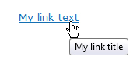
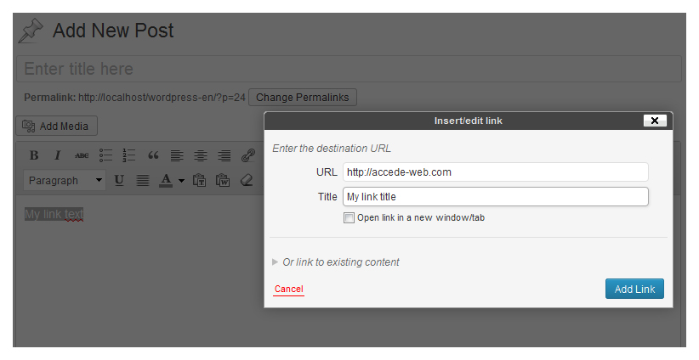
When creating a link in the publishing software, the user can enter the link title
in the “Title” field of the “Insert/edit link” dialog box.
To be customized
In the section above, specify the feature(s) used for entering link titles.
Note
Link titles should be limited to a strict minimum, as they cannot be displayed or accessed in some contexts (touch screens, navigating from the keyboard, some screen readers, etc.).
They should therefore be used as a last resort, when it is not possible to make the link text completely explicit.
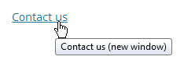
For example, when a “Contact us” link automatically opens up a new window,
a link title such as “Contact us (new window)” could be added.

Warning
If a link title is entered, it must imperatively include the same information as the link text and add new information. In other words:
- The link title must not simply copy the link text.
- The link title must not contain new information only.
For example, a “News” link text with a link title “New window” or “News” is to be avoided. On the other hand, a “News” link text with a link title “News (new window)” is appropriate.

Make images accessible
When images are inserted into content, an alternative text may be needed.
This text is essential for blind people, because it will be read instead of the images that cannot be viewed. This text is also displayed when the images cannot be loaded.
The content of the alternative text depends on the purpose of the image, i.e. on whether the image is decorative, informative, or a link-image. The following paragraphs describe how to write the alternative text depending on the type of image.
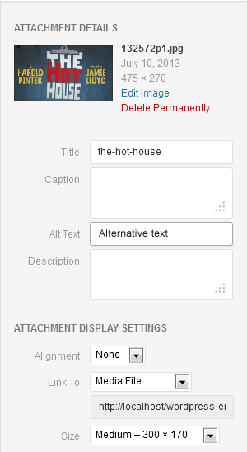
When inserting an image, the “Alternative text” field is used
to enter the ALT or alternative text for the image.
To be customized
In the section above, describe how to enter the alternative text in the publishing software used.
Tip
To help you decide if an alternative text is required, ask yourself if its absence would affect your understanding of the content. If the answer is “yes”, then you need to enter an alternative text; if not, you can leave the alternative text field empty.
The sections below describe how to enter alternative text depending on the type of image:
- 4.1. Decorative/illustrative images: do not write an alternative text
- 4.2. Informative images: write an alternative text
- 4.3. Link-images: write an alternative text that describes the purpose of the link
- 4.4. Complex informative images: write a short alternative text as well as a detailed description

Decorative/illustrative images: do not write an alternative text
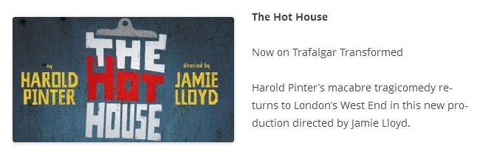
This image is placed next to the text. All the information in the image is also included
in the text besides it. If this image is absent, no information is lost.
For this type of image, there is no need to enter an alternative text.
You can leave the field empty.

Informative images: write an alternative text
Images meant to inform must be provided with alternative text that is equally meaningful. If a user cannot see the image, what information would they need to understand the content the image is conveying? Alternative text should be clear and concise.
For the image below, a suitable alternative text would be “The Hot House, by Harold PINTER directed by Jamie Lloyd”.
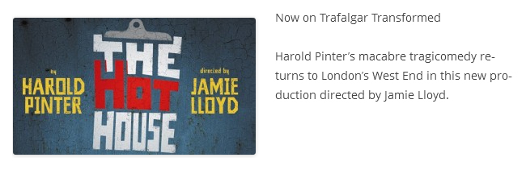
The same image is placed next to this text. In this case, the information “The Hot House”
is missing from the text. The image serves to communicate additional information.

Link-images: write an alternative text that describes the purpose of the link
If an image is the only content within a link, that image must be given alternative text that is unique and describes its purpose and destination.
If the image below points to the reservations page for the event “The hot house” and has no accompanying text, an appropriate text alternative would be “Reserve a ticket for The Hot House (by Harold PINTER and directed by Jamie LLYOD)”.

This image has no accompanying text and is clickable.
The link points to the reservations page for the event.
Note
Image and text in the same link
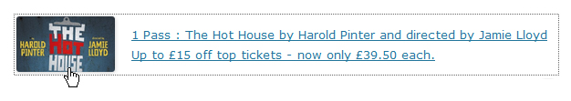
When an image and text are in the same link, the alternative text should not repeat the information that is already in the link text.
For the image above, the alternative text field can be left empty.
Warning
It is counterproductive to begin the alternative text with expressions such as “Open the news page”.
“News” would be sufficient as alternative text.

Complex informative images: write a short alternative text as well as a detailed description
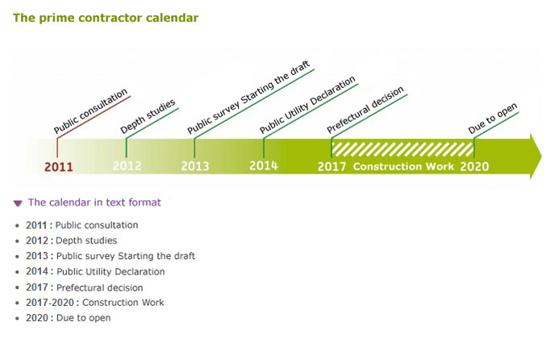
As the calendar above conveys complex information in image form, an accordion button with the text “The calendar in text format” is provided to display a detailed description of the image.
For this type of image, you need to write:
- A short alternative text.
- A detailed description under the image or on another page.
The short alternative text should:
- Briefly describe the purpose of the image.
- Indicate where the detailed description is found.
For the complex image shown above, an appropriate short alternative text would be “Roissy-Picardie project calendar (detailed description below)”.
The text description must convey the same or equivalent information as what is conveyed by the image. It must be available either on the same page, or on another page via a link available near the image.

Use bulleted and numbered lists correctly
When bulleted and numbered lists are included in the content, use the appropriate tools in the publishing software for this purpose, rather than entering dashes or numbers from the keyboard with carriage returns.
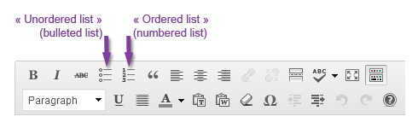
Use the buttons “Unordered list” (bulleted list) or “Ordered list (numbered list)
instead of dashes and carriage returns.
To be customized
In the section above, describe the tools for creating lists.
Note
Difference between a numbered list and a bulleted list
Use a numbered list when the order of items is important, in other words the information will not be understood if the items are written in a different order (steps for following a recipe, items classified in alphabetical order, etc.).
Use a standard bulleted list when the order of items is unimportant.
Warning
Lists must only be used to highlight a series of items. It is important not to use them simply to display a bullet point before a paragraph, for example.

Write content in an accessible way

Keep accents on capital letters
Letters must retain their accents, even when capitalized. One reason this is important is so that screen readers will reproduce the sound better.
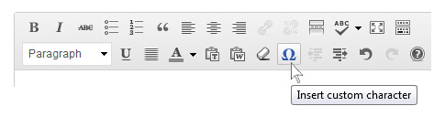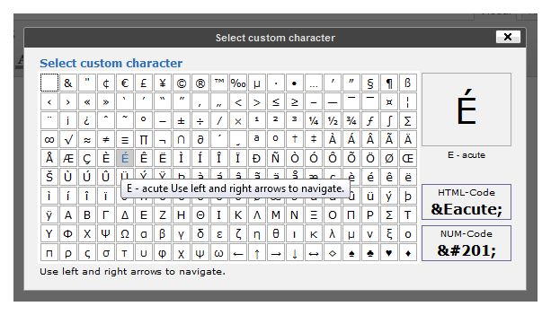
The "Insert custom characters" function is used to insert special characters in the content.
To be customized
In the section above, specify the procedure for inserted accented capital letters.

Tip
Capital letters can also be directly typed from the keyboard by using specific keyboard shortcuts.

Expand the first occurrence of acronyms or abbreviations to their full meaning within content
When abbreviations or acronyms are used in the content and their meaning is not immediately obvious, the full form of the abbreviation must be provided the first time the abbreviation is used on the page.
Example:
A Registered Retirement Savings Plan (RRSP) is a government-regulated investment account with special tax benefits to help you maximize your retirement savings. Deductible contributions to an RRSP help reduce your taxes, and any income you earn on your investments while in the plan grow tax-deferred.
Further down the page you can use the abbreviation “RRSP” on its own when you want to write about it.
Warning
When terms are habitually used in their abbreviated forms, do not expand it in the webpage (e.g., NATO, SMS, HTML,“etc.”…)

Identify inline quotes and block quotes
When quotes are included in the content, use the tools provided by the publishing software for this purpose rather than using simple paragraphs inside quotation marks.
By doing so, assistive devices such as braille displays or screen readers can announce the presence of a quote.
There are two types of quotation:
- Inline quotes that are inserted within a sentence or paragraph.
- Block quotes that form isolated blocks and can be read outside their context.
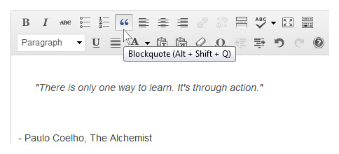
The “Block quote” button is used to transform the selected text into a block quote.
If the publishing software does not have a feature for entering inline quotes, simply use quotation marks.
To be customized
In the section above, specify the procedures for entering inline and block quotes.
Delete this recommendation if the publishing software does not have tools for inline and block quotes.
Warning
Quotes and block quotes must only be used to highlight quotes.
They should not be used to format text in italic, for example, or obtain an indented paragraph.

Identify language changes
As a general rule, make sure the same language is used for all content.
If exceptionally some of the text needs to be written in a different language from the rest of the page, use the tools in the publishing software to indicate the change of language.
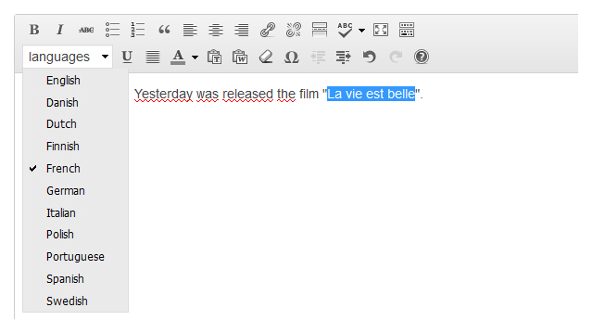
The “Language” option in the publishing software is used to indicate expressions
written in a different language from the main language.
To be customized
In the section above, specify the features for indicating a change of language.
Delete this recommendation if the publishing software does not have a feature for this, and ask contributors to limit the use of terms in foreign languages.
Note
There is an exception to this recommendation.
Language changes do not need to be declared for:
- Proper nouns.
- All the words with a foreign origin, which are pronounced and can be properly understood with the accent of the main language or which are included in its dictionary.
For example, you do not need to declare a change of language for the following words and expressions:
- Coup d’état.
- Au pair.
- Vinaigrette.
- Charles de Gaulle.
- Etc.

Do not refer to an item by indicating its color, shape, or position alone
If you only refer to the color, shape or position of an element to identify it, some users will be unable to locate it on the page.
For example, you should replace:
- “Click on the round button” by “Click on the Confirm button”.
- “For more information see the insert on the right” by “For more information see the insert on the right (Wiltshire contract)”.

Use colors and contrast correctly

Ensure that the contrast between text or images and background color is sufficient
As a general rule, the colors proposed by default in the graphic charter should not be modified, in order to retain visual consistency throughout the website or application.
You can often let the publishing software handle the styles that are automatically applied to content when pages are displayed.
Nevertheless, it is sometimes useful to define customized colors directly in the content.
In that case, make sure that there is enough contrast between the text color and the background color.
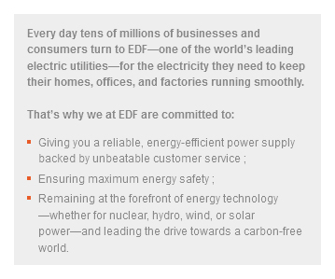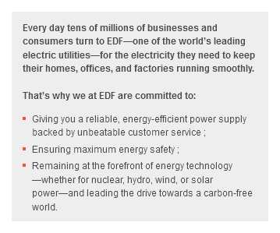
Tip
If you are not sure about the contrast, it probably means that there is not enough. In that case, do not hesitate to increase it.
Text that is included in images or rich content, such as animations, also needs to be given sufficient contrast against the background.
Warning
If the images or rich content provided for publication do not have sufficient contrast, they should be returned to the person who provided them and a new, optimized version should be obtained.

Do not convey information by colour alone
Do not use color as the sole differentiator of information in content. This applies to text, and images, and rich content.
For example, a chart might show different data segments using coloured lines. However, changing the lines’ thickness or making them dotted or dashed would also help convey the information in a way that doesn’t rely on the user having to discern the colours.
Tip
The first way to test this principle is to imagine the page printed in black and white, and see if all the information can still be understood. Would you be able to see and understand the information it contains?
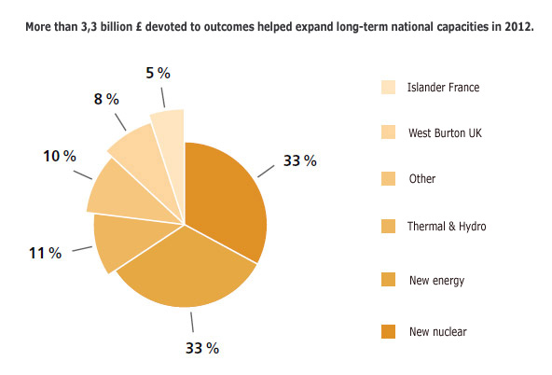
In this first version, the information in the pie chart can only be understood by associating
a color with the corresponding segment of the pie chart.
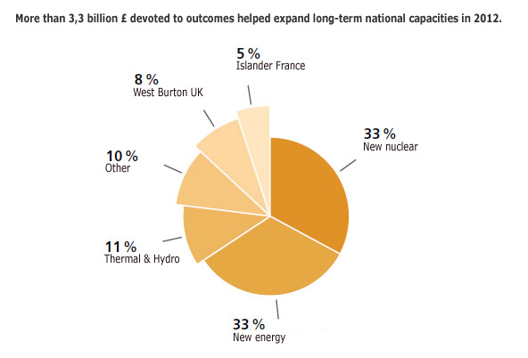
While this second version can be understood even if the colors are removed.
Warning
If the images or rich content have been supplied for publication with information conveyed by color only, they should be returned to the person who provided them and a new optimized version should be obtained.

Use rich content and multimedia correctly

Associate a detailed description with rich content (charts, maps, Flash animations)
Rich content can sometimes convey so much information that a detailed description needs to be added. This is often the case with charts and informative animations, among others.
In these circumstances, a detailed description in text form must be added.
It must convey the same or equivalent information as what is conveyed by the complex rich content. It must be available either on the same page, or on another page via a link available near the rich content.
The calendar above is a Flash animation that conveys complex information. A link, with the text “Calendar in text format”, sends the user to a detailed description of the rich content.
Warning
If the complex rich content has been supplied for publication without a detailed description, it should be returned to the person who provided them in order to obtain a detailed description.

Ensure that moving content can be paused
For animations or any other moving content, a means of pausing and restarting the movement must always be included.
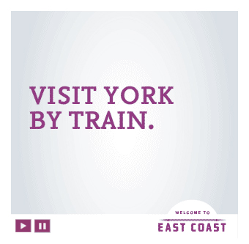
On this animation, a button is provided to pause the video.
Warning
If animations or moving content have been supplied for publication without a system for pausing them, they should be returned to the person who provided them and a pausing system should be added.

Ensure that videos have a transcription, closed captions (and audio description if applicable)
A user who is hard of hearing will benefit from having closed captions to relay anything spoken or heard into viewable text, while one with a severe visual impairment would benefit from a separate audio track describing the visual content of the video.
In order for a published video to be accessible, the following elements must accompany the video, in order of priority:
- A complete transcription.
- Captions.
- An audio description.
The publishing software and video player used supports these three features.

To be customized
If necessary, update the previous section to specify the features supported by the publishing tool and the video player used.

Transcripts
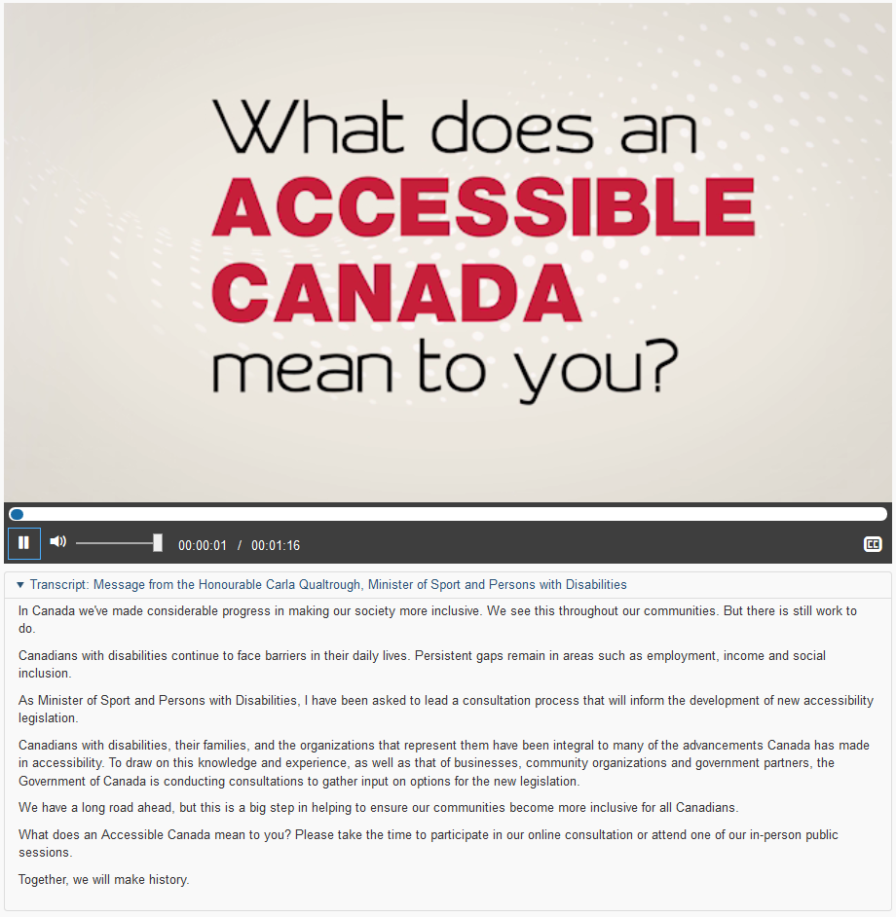
The transcription must provide in text form all the information provided by the video (speech, messages displayed on the screen, etc.). If necessary, images may be included in the transcription.

Captions
The captions must show in text format all the audio content included in the video.
They must not be displayed directly in the video, but must be attached to it in a separate text file (often an .xml or .srt file).

Audio descriptions
The audio description is added to the soundtrack.
It must provide in audio format all the information that is only accessible by images.
In the same way, this audio track must not be included directly in the video, but attached in a separate audio file (usually an .mp3 file).

Warning
If videos have been supplied for publication without these three features, they should be returned to the contributor and these features should be added.
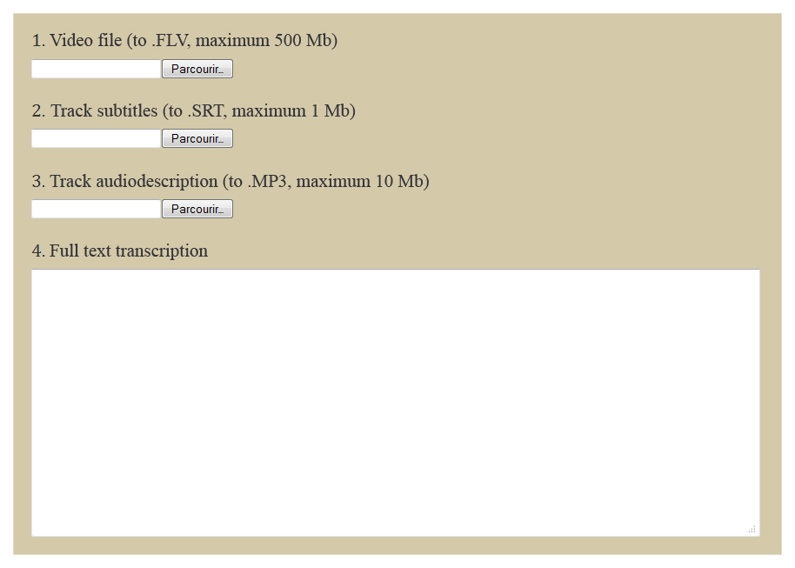
When adding a video, the publishing software offers the possibility of adding captions, an audio description file, and a box for entering the transcription.
To be customized
In the section above, enter the functionalities or fields used in the publishing software to add a transcription, a captions file and an audio description file.

