
Accessibility guidelines for graphic design
Date | Version | Author | Status / comments
Nov 3rd, 2018 | 3.0 | Atalan
In partnership with:
Air Liquide – Atos – BNP Paribas – Capgemini – EDF – Generali – SFR – SNCF – Société Générale – SPIE
Observers:
AbilityNet (UK) – Agence Entreprises & Handicap – AnySurfer (Belgium) – Association des Paralysés de France (APF) – Association Valentin Haüy (AVH) – CIGREF – Design For All Foundation (Spain) – ESSEC – Handirect – Hanploi – Sciences Po – Télécom ParisTech
Acknowledgments
Special thanks to our AcceDe Web partners for their input and commitment:

Thanks to their support, participation in the working groups, proofreading of documents, and testing of manuals, the partner companies have provided valuable input to the Accede Web project. This has made it possible to create manuals that successfully meet the needs of the different stakeholders of a web project. These companies are also contributing to making the web more accessible by authorizing the free distribution of this content.
We would also like to thank the following observers of the AcceDe Web project whose actions raise awareness of the AcceDe Web manuals and aid their distribution: AbilityNet (UK), Agence Entreprises & Handicap, AnySurfer (Belgium), Association des Paralysés de France, Association Valentin Haüys, CIGREF, Design for All foundation (Spain), ESSEC, Handirect, Hanploi, Sciences Po and Télécom ParisTech.
We thank all the members of the review committees for the quality and relevance of their comments:
- English version: Robin Christopherson (UK - AbilityNet), Ramon Corominas (Spain - Technosite), Deborah Edwards-Onoro (USA - Lireo Design), Thomas Frandzen (Denmark - Agency for Digitisation, Ministry of Finance), Char James-Tanny, (USA - a11yBos), Matt May (USA – Adobe), Sophie Schuermans (Belgium – Anysurfer), Jared Smith (USA - WebAIM), Christophe Strobbe (Germany), Gijs Veyfeyken (Belgium – Anysurfer)
- French version: Benjamin Ach (accessibility expert), Vincent Aniort (APF), Jean-Baptiste Audras (University of Grenoble), Claire Bizingre (accessibility consultant), Victor Brito (accessibility consultant), Anna Castilla (Provaltis), Ève Demazière (Sciences Po), Nicolas Fortin (French Ministry of Media and Culture), Marc-Étienne Vargenau (Alcatel-Lucent) and Éric Vidal (Fédération des aveugles de France), as well as all the teams of our partner companies.
Finally, we would like to thank Laurent Bracquart and Johan Ramon, Christophe Pineau and Marion Santelli of Atalan for their dedication and commitment to this initiative.
Sébastien Delorme, Sylvie Goldfain,
Atalan (contact@atalan.ca)
Table of contents
Introduction 5
Context and objectives 5
Who should read this document, and how to use it? 5
Contact 5
License agreement 5
1. Navigation 7
1.1. Provide a breadcrumb 7
1.2. Provide at least two of the following navigation methods: main menu, site map, and search engine 7
1.3. Make the current position visually different in each navigation system 8
1.4. Make sure that the navigation is visually consistent 9
1.5. Provide a help page 9
1.6. Provide an accessibility page 10
1.7. Provide skip links 10
2. Text and symbols 12
2.1. Keep accents on capital letters (for French, Spanish and any language containing accented characters) 12
2.2. Do not justify the text 12
2.3. Associate text with each ambiguous symbol 12
3. Colours 14
3.1. Make sure that there is sufficient contrast between the content and the background or propose an alternative with contrast 14
3.2. Make sure that information is comprehensible, even if the colours are absent 16
4. Links and buttons 17
4.1. Provide an explicit link text for each link and each button 17
4.2. Distinguish links from the surrounding text 18
4.3. Plan sufficiently large and spaced hotspots 18
5. Documents 19
5.1. Indicate the size and format of each document that can be downloaded 19
5.2. Indicate the language of each document available for download written in a foreign language 19
6. Tables 21
6.1. Provide a heading for each data table 21
7. Forms 22
7.1. Provide an explicit label for each form field 22
7.2. Use identical labels for form fields that have the same purpose 22
7.3. Place each label next to the corresponding field 23
7.4. In long forms group similar form fields together and give them a heading 24
7.5. Provide a submit button at the end of each form 25
7.6. Provide an explicit button text for each button 26
7.7. Clearly indicate mandatory fields 27
7.8. Provide help for entering data 27
7.9. Provide explicit error messages and suggestions for correcting errors 29
7.10. Provide a confirmation message 30
7.11. Provide a way of returning to the previous steps on forms with multiple steps 30
7.12. Provide a summary of all the data entered before final submission of the form 31
7.13. Provide a security test that is a logical test rather than a CAPTCHA 31
7.14. Provide an alternative to each CAPTCHA that is only a sound or only a visual test 34
8. Multimedia 35
8.1. Provide a heading or summary for all video and audio content 35
8.2. Provide a way of accessing the text transcript of all video and audio content 36
8.3. Provide a way of controlling the progress and volume of all video and audio content 37
8.4. Provide a way of displaying the closed captions 37
8.5. Select a style for the captions that makes them readable 38
8.6. Provide a way of activating the audio description 39
8.7. Provide a method for stopping all animated content 39
8.8. Do not automatically trigger the sound 40
9. Additional Guidelines 41
To comply with level A (WCAG 2.0) 41
To comply with level AA (WCAG 2.0) 41
To comply with level AAA (WCAG 2.0) 41

Introduction

Context and objectives
This documentation brings together all the accessibility specifications to consider during the graphic design and ergonomics stages of website or web application development (wireframes, prototypes, mock-ups, etc.) to ensure WCAG 2.0 compliance.
By taking these recommendations into account you can plan for the inclusion of a maximum number of accessibility criteria before the technical integration and development phases.
Several recommendations in this manual can also apply to the functional design of a website or web application (inclusion of a search engine, functionalities for a media player, etc.).
This manual is part of a set of four complementary manuals that can be downloaded from AcceDe Web website:
- Accessibility guidelines for graphic design (this manual).
- Accessibility guidelines for HTML, CSS and Javascript.
- Accessibility guidelines for the main rich interfaces.
- Accessibility guidelines for editors (template).

Who should read this document, and how to use it?
This document should be given to the stakeholders and/or service providers who create the functional specifications and graphic mock-ups. It should be used in addition to the project specifications, company graphic charter, and creative briefs. The recommendations may be supplemented with others, or left out, according to the circumstances—the project manager is often the most appropriate person for this task.
The recommendations should be taken into account during the graphic design phase, and for some of them, when creating storyboards and functional specifications.
Note
The online version of these guidelines comes with many examples, links to complementary resources, etc. It is available at: http://www.accede-web.com/en/.

Contact
Please send any comments about this document to Atalan, the coordinator of the AcceDe Web project, at the following email address: accede@atalan.ca.

License agreement
This document is subject to the terms of the Creative Commons BY 3.0 license.
You are free to:
- copy, distribute and communicate the work to the public,
- change this work,
under the following conditions:
- Mention of the authorship if the document is modified:
  - You must include the Atalan and AcceDe Web logos and references, indicate that the document has been modified, and add a link to the original work at http://www.accede-web.com/en.
  - You must not in any circumstances cite the name of the original author in a way that suggests that he or she endorses you or supports your use of the work without its express agreement.
  - You must not in any circumstances cite the name of partner companies (Air Liquide, Atos, BNP Paribas, Capgemini, EDF, Generali, SFR, SNCF, Société Générale and SPIE), or the organizations which have supported this initiative (AbilityNet, Agence Entreprises & Handicap, AnySurfer, Association des Paralysés de France (APF), CIGREF, Design For All Foundation, ESSEC, Handirect, Hanploi, Sciences Po and Télécom ParisTech) without their express agreement.
The Atalan and AcceDe Web logos and trademarks are registered and are the exclusive property of Atalan. The logos and trademarks of partner companies are the exclusive property of Air Liquide, Atos, BNP Paribas, Capgemini, EDF, Generali, SFR, SNCF, Société Générale and SPIE.

Navigation

Provide a breadcrumb
A breadcrumb must be present on each page:
- It must show the current position of the user in the website's hierarchical structure in relation to the home page.
- It must allow the user to navigate up the hierarchy of parent pages to the home page.
- It must always be positioned in the same place on each page.
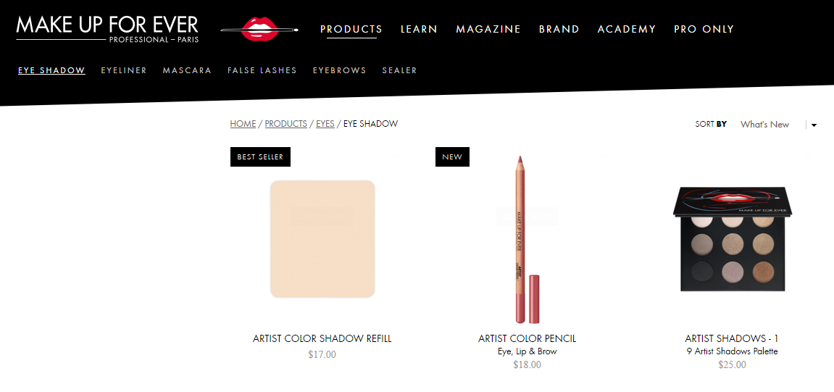
Example of a breadcrumb
Note
Breadcrumbs are not mandatory on the home page.
Tip
It is considered good practice to visually distinguish the last item of the breadcrumb if this is the current position.

Provide at least two of the following navigation methods: main menu, site map, and search engine
At least two of the following three navigation methods must be available in the website:
- A main menu.
- A site map that shows the structure of the website, and at least allows the user to access all sections and functions of the website.
- A comprehensive search engine that provides a search on all the content (text, documents, videos, etc.).
These items should be available in the same place on each page throughout the website.
Note
You can, of course, choose to have all three navigation methods in the same website.

Make the current position visually different in each navigation system
The current item must have a different appearance in each navigation system.

In this first example of a menu, the currently active section (“Newsletter”) is indicated
by a different text and background color, and by the arrow pointing down.
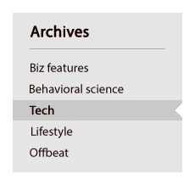
In this second example of a menu, the currently active page (“Tech”) is indicated
by a different background color, bold characters and a notch mark.
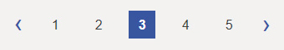
In this pagination example, the currently active page (“3”) is indicated
by a different text and background color, and bold characters.
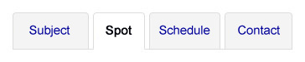
In this example of a tab system, the currently active tab (“Spot”) is indicated
by a different text and background color, and bold characters.

In this example of a navigation system within a news carousel, the currently active
panel is indicated by a dot of a different color and size.
Warning
Make sure that the means for visually distinguishing current items in the navigation system are not only based on color. Color can be completed with:
- Bold characters.
- An icon.
- A different text size.
Note
It is also highly recommended to have a different appearance for the mouse-over of menu items.

Make sure that the navigation is visually consistent
Throughout the website, the appearance and position of items should be consistent (though not necessarily identical):
- Navigation menus.
- Search engine.
- And, generally, all the items that appear on every page (logos, useful links, etc.).
Note
The appearance of the home page may be different than the rest of the website.

Provide a help page
You should plan to provide a help page.
It must provide:
- Informations that helps users to consult and use the website.
- The contact details of a person in the company who can be reached if there are any problems consulting and/or using the website.
A link to the help page must be available in the same place from all the pages in the website.
Notes
- This help page and its link can be labeled "Help", "Navigation help", "Assistance" or even "How to navigate".
- An accessibility page must be provided in addition to this help page. Please note that both of these pages can be combined.

Provide an accessibility page
An accessibility page should be planned.
It should provide information regarding the accessibility level of the website.
Notes
- This accessibility page and its link can be labeled "Accessibility" or "Accessibility policy" for instance.
- A help page must be provided in addition to this accessibility page. Please note that both of these pages can be combined.

Provide skip links
A “Go to content” skip link must appear at the top of at least one of the graphic mock-ups. The “Go to content” skip link must be displayed in the same place at the top of each page.
Tip
It can be hidden by default, if you prefer.
In that case, during the development phase you will need to make it visible in some situations (navigation with the keyboard, version for mobile phones, etc.).
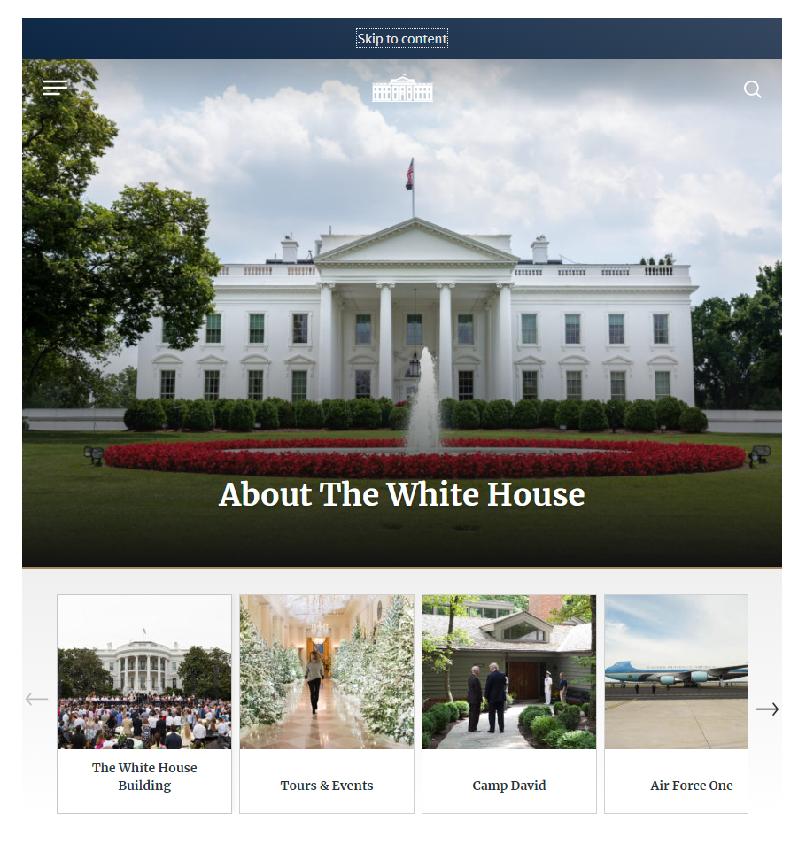
Example of a “Skip to content” skip link situated at the top of the page.
Note
Links such as “Go to menu”, and “Go to search”, can also be added besides the “Go to content” link if these items are not near the top of the page.

Text and symbols

Keep accents on capital letters (for French, Spanish and any language containing accented characters)
While writing in a language containing accented characters, accents must be kept, even on capital letters.
Therefore you should write “Belle Époque” instead of “Belle Epoque”, “DÉTENTE” rather than “DETENTE” etc.
Note
You are strongly encouraged not to write long sections of text in capital letters, because they make reading tiresome.

Do not justify the text
Text must not be justified.
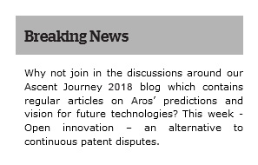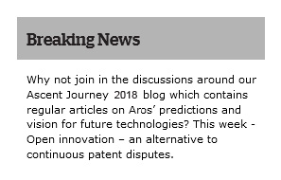
In this first example, the justified text leads to irregular and large gaps
between words, which may lead to difficulties in reading the text.

Associate text with each ambiguous symbol
If symbols whose meaning is not obvious are used, they must:
- Be accompanied by text that clarifies the meaning.
- Be located near the accompanying text.
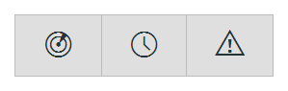
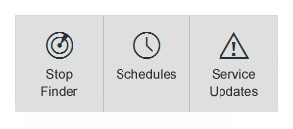
In this example, symbols that could be ambiguous
are combined with text that makes them more explicit.
Note
If it is not practical to associate a text with specific symbols whose meaning may not be clear (lack of space in the mock-up, for example), some solutions may be found later on in the development phase (by adding tooltips, for example).
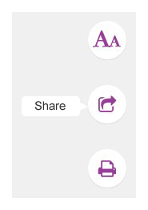
In this example, symbols that could be ambiguous
are combined with text displayed in tooltips.
Nevertheless, these are compromise solutions that are less effective than optimising the symbol directly with associated text.

Colours

Make sure that there is sufficient contrast between the content and the background or propose an alternative with contrast
The contrast between the colors and the background must be sufficient for all items present (text, images, videos, etc.).
Note
It is also important to provide a sufficient contrast between an informational icon (not completed with text) and the background colour.

Examples of sufficiently contrasted pictograms.

Minimum contrast ratio for a AA WCAG 2.0 compliance
The minimum contrast ratio to reach the AA level requirement of WCAG 2.0 depends on the font weight.

For a non-bold text
- The colour of a non-bold text with a font size lower than 18pt should have at least a contrast ratio of 4.5 with the background colour.
- The colour of a non-bold text with a font higher or equal to 18pt should have at least a contrast ratio of 3 ratio with the background colour.

For a bold text
- The colour of a bold text with a font size lower than 14pt should have at least a contrast ratio of 4.5 with the background colour.
- The colour of a non-bold text with a font higher or equal to 14pt should have at least a contrast ratio of 3 ratio with the background colour.
Note
The kind of font used does not impact the ratios.

Colour Contrast Analyser
To test the contrast, you could use, for example, the Contrast Analyser tool for Windows and Mac OS, which you can download free at https://developer.paciellogroup.com/resources/contrastanalyser/.
Warning
Be careful when using shading, color gradients or patterns as background for content.
Tip
- The Contrast-Finder tool can be used to find sufficiently contrasted color combinations : https://app.contrast-finder.org/?lang=en.
- The Color Safe tool can be used to generate sufficiently contrasted color palettes : http://colorsafe.co.
- A11yColor (http://a11yrocks.com/colorPalette) can be used to automatically calculate the contrast of several colors.

Alternative style guidelines
If it is not practical to optimize the contrast, then you can create alternative style guidelines that offer sufficient contrast.
Alternative style guidelines do not necessarily push the contrast to the limits (for example, black on white, or white on black), but provide rules so that the association of colours is optimized satisfactorily.

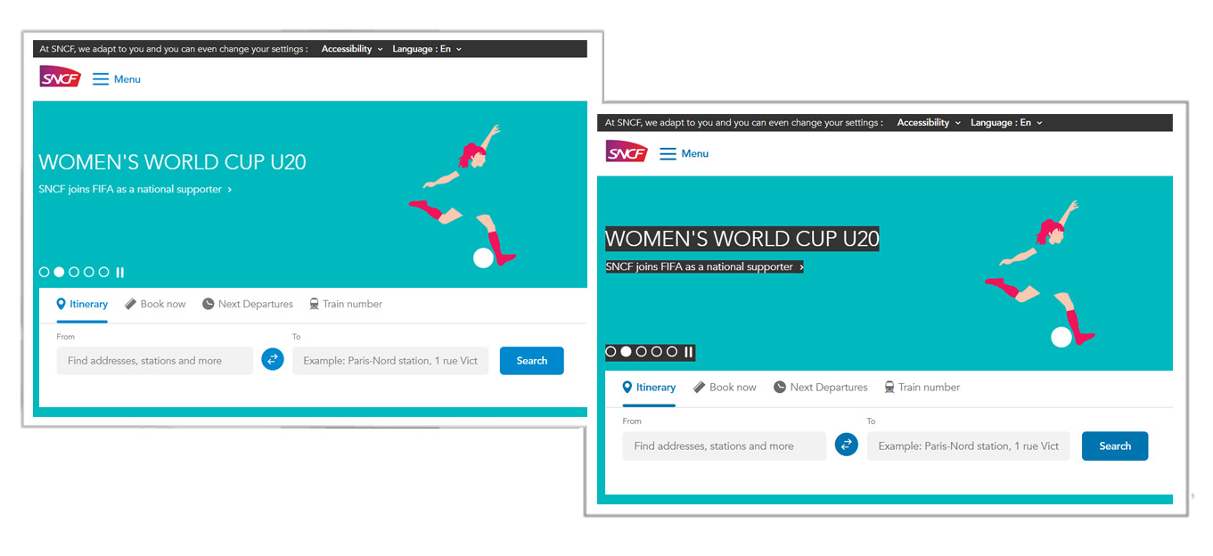
In this example, alternative style guidelines that are sufficiently contrasted (on the right capture)
can be activated from the button “Accessibility” which opens a menu
containing some accessibility parameters.

Make sure that information is comprehensible, even if the colours are absent
Information must not be conveyed solely by colour.
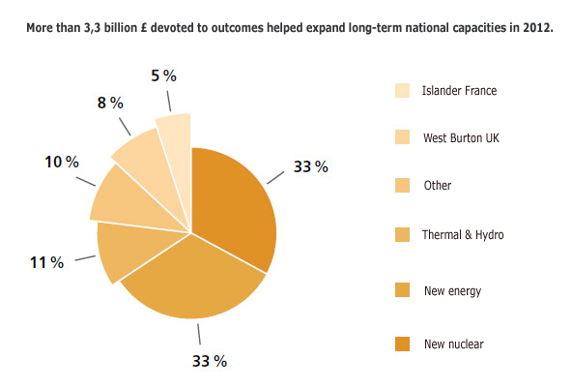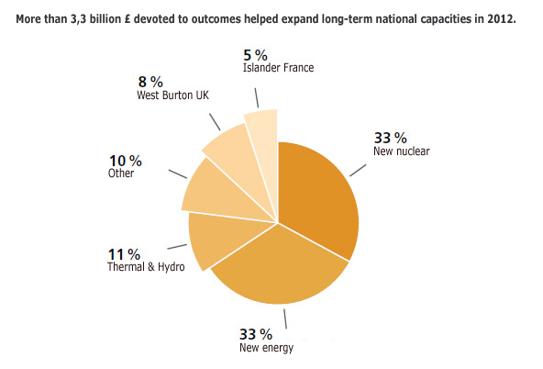
In the first example, the information in the pie chart can only be understood by associating each segment with a colour; the second version is comprehensible even if the colours are absent.

Links and buttons

Provide an explicit link text for each link and each button
An explicit link text must be provided for each link and each button. In other words, the destination of the link or the function of the button must be perfectly comprehensible just by reading its text.
The following link and button texts are therefore to be avoided:
- "Read more"
- "More information".
- "Click here".
- Etc.
They should be replaced by such texts as:
- "Mr. Cameron's statement (read more)".
- "More information on the Wiltshire contract".
- "Discover our welcome offer".
- Etc.
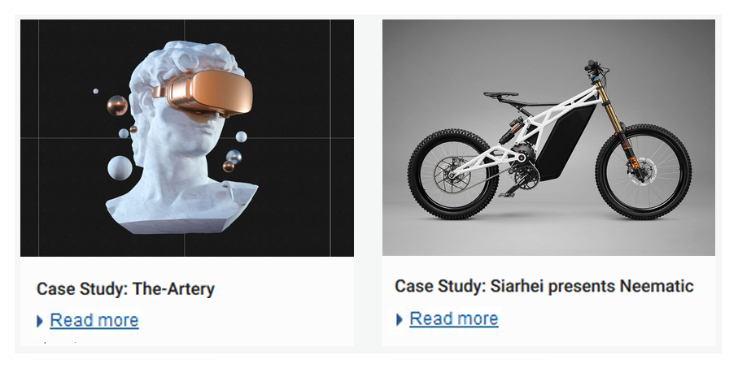
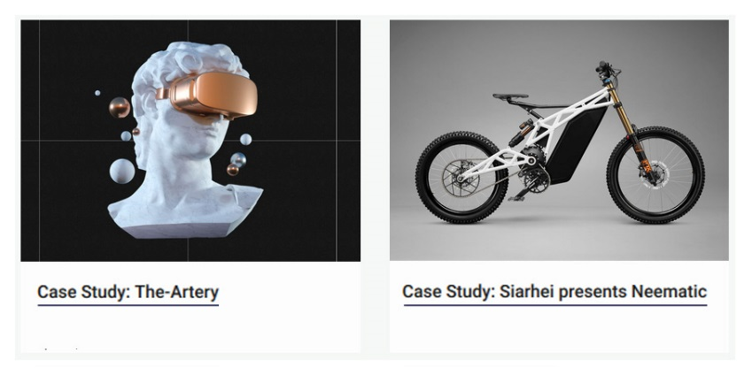
In this example, the “Read more” links have been deleted,
and the links placed directly on the heading of the case studies.
Note
If it is not practical to make some link or button texts explicit (lack of space in the mock-up, for example), there are other solutions that can be used later in the development phase.
Nevertheless, this is a compromise solution that is less effective than directly optimizing the link or the button with an explicit link text.

Distinguish links from the surrounding text
When links are included in content, they must be distinguished from the text surrounding them. For example, the links could be underlined.
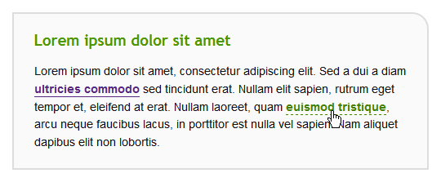
Example of a satisfactory visual distinction between a link and its surrounding text.
Note
This rule does not apply to links included in link groups (menu items, for example), because their function is obvious.
Warning
You are strongly advised not to apply underlining to other elements than links.
Tip
In addition to this recommendation it is also a good idea to provide the mouse-over appearance of links in the mock-ups.
The change of appearance when mousing over the links must not be limited to a change of color (other possible additions : removed underlining, bold characters or an added icon, etc.).

Plan sufficiently large and spaced hotspots
A good accessibility practice is to make sure that hotspots (links and buttons, for instance) are sufficiently large (at least 0.5 x 0.5 inch, i.e. 33 x 33 pt) and well-spaced because it will make navigation easier for mouse users or those using tactile screen.

Documents

Indicate the size and format of each document that can be downloaded
For each link that points to a document that can be downloaded, the following information must be included in the link text:
- Title of the document.
- Format of the document.
- Size of the document.
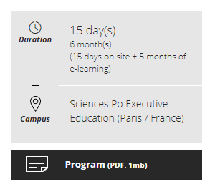
Example of indication of size and format of a PDF document.

Indicate the language of each document available for download written in a foreign language
Whenever a link points to a document available for download in a different language than the main language of the page, then the language of the document must be indicated in the link text.
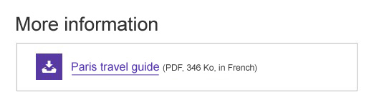
Example of an indication of the language of a PDF document.
Note
If it is not practical to add this information in the link texts (lack of space in the mock-up, for example), there are other solutions that can be used later in the development phase.
Nevertheless, this is a compromise solution that is less effective than directly optimizing the link text.
Tip
Another solution is to write the title of the document to be downloaded in the language of its content.
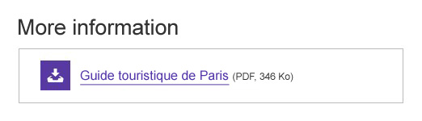

Tables

Provide a heading for each data table
Whenever data tables are used, they must be immediately preceded by a heading that clearly and briefly describes the content.
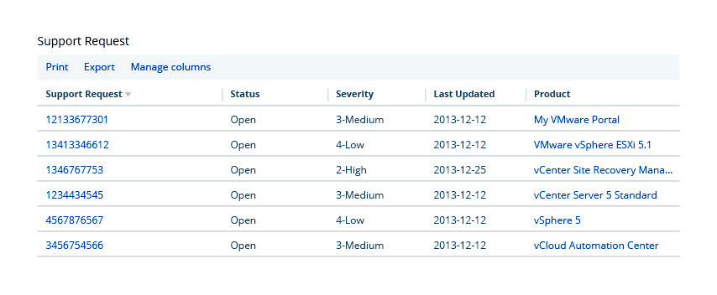
Example of a data table with a heading.

Forms

Provide an explicit label for each form field
An explicit label must be provided for each form field.
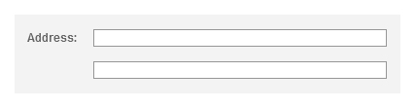
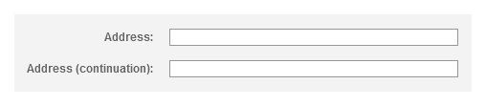
In this example, a label has been added to the field for the second line of the address.
Note
If it is not practical to add a label for each field (lack of space in the mock-up, for example), there are other solutions that can be used later in the development phase.
Nevertheless, this is a compromise solution that is less effective than directly optimizing the form field label.
In this example, the “Search” form field have an explicit label.

Use identical labels for form fields that have the same purpose
Whenever you have two or more fields with exactly the same purpose on the same page, their label must also be identical.
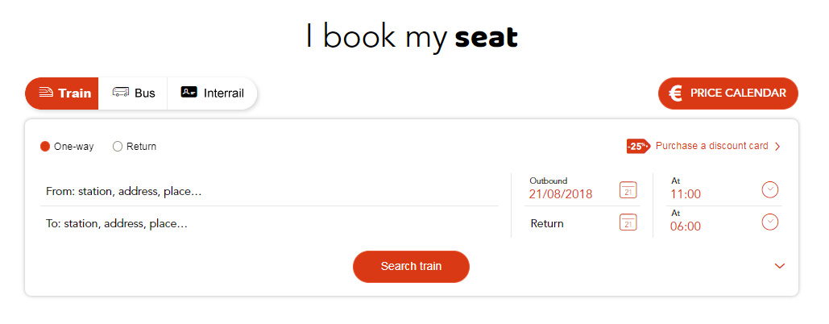
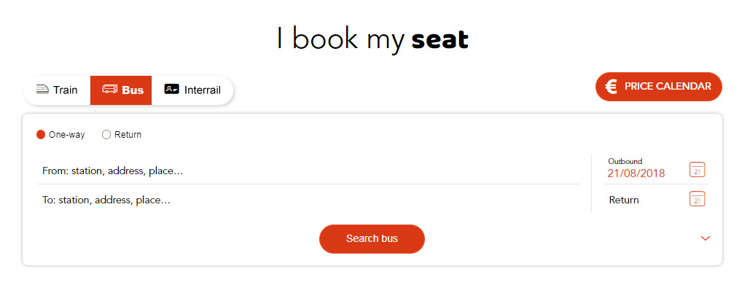
In this example, regardless of the tab, the labels “From” and “To” are identical. It would have been bad practice, for example, to put “To” on one tab and “Arriving in” on another.

Place each label next to the corresponding field
Each label must be placed close to the field to which it is attached. There should only be a few pixels that separate a label from its corresponding field.
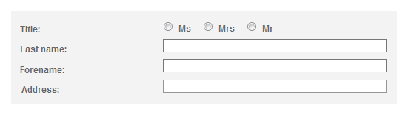
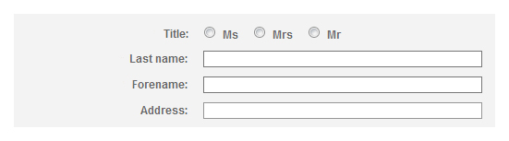
In this example, labels are right-aligned so that they are next to the corresponding fields.
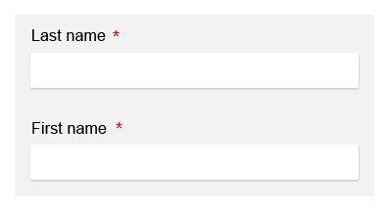
In this example, the labels are in the right position,
close to the corresponding form fields.

In long forms group similar form fields together and give them a heading
Whenever fields of the same type are present in long forms (for example, address fields), these must be:
- Visually grouped together.
- Introduced with a clear and concise heading.
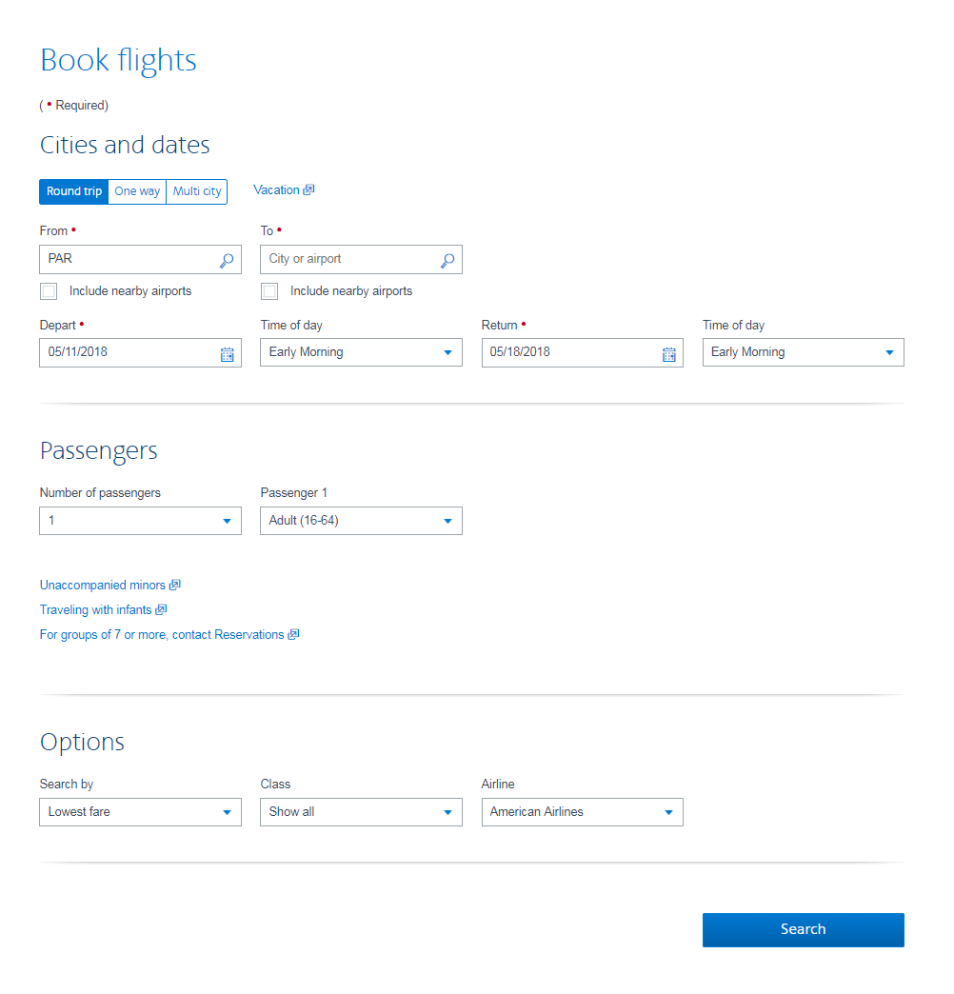
In this example, the fields are grouped by categories: “Cities and dates”, “Passengers” and “Options”.

Provide a submit button at the end of each form
A submit button should be provided in each form, and placed at the end of the form.
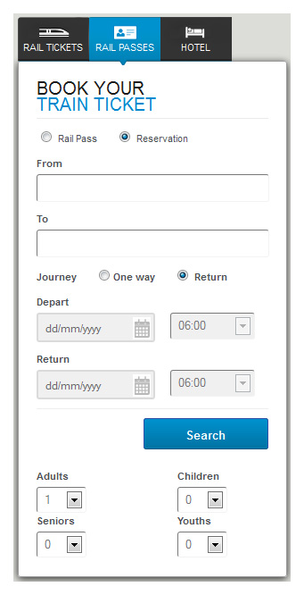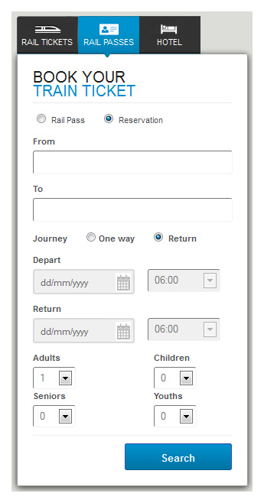
In the first example, the options “Adults”, “Seniors”, “Children” and “Youths” are placed after the “Search” submit button. Some users may omit to enter this information. For this reason, it is important to position the submit button at the end of the form, as in the second example.
Note
In some circumstances, you do not need to provide a button.
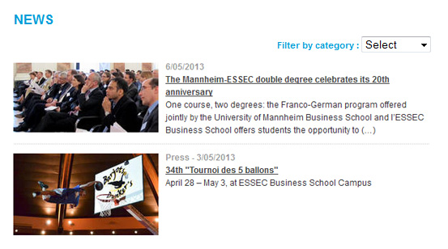
This is the case, for example, with a drop-down list for sorting a list of results dynamically, as the action is triggered dynamically when the user makes a choice.

Provide an explicit button text for each button
An explicit button text must be provided for each button. The purpose of the button must be easily understood just by reading the button text, even if it is read out of context.
Button texts with the following text should therefore be avoided:
- "OK".
- "Validate".
- "Confirm".
- Etc.
They should be replaced by button texts such as:
- "Register".
- "Go to step 2".
- "Confirm payment".
- Etc.
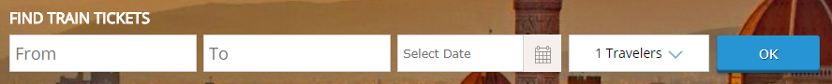

In this example, the “OK” button has been replaced by a “Find Tickets” button, which is more precise.
Note
If it is not practical to add a button text for some buttons (lack of space in the mock-up, for example), there are other solutions that can be used later in the development phase.
Nevertheless, this is a compromise solution that is less effective than directly optimizing the button text.
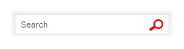
In this example, the image button represents a magnifying glass.
It will be made accessible during the technical phase

Clearly indicate mandatory fields
On each form, mandatory fields should be clearly indicated:
- A distinctive sign (statement, symbol, pictogram, etc.) must be provided in the label of each mandatory field.
- A statement at the beginning of the form must indicate that the symbol or pictogram stands for a mandatory field.
Note
- If all the form fields are mandatory, then the statement “All fields are mandatory” may be sufficient.
- You can also indicate at the beginning of a form that all fields are mandatory, except where there is an indication that the field is optional in the field label.
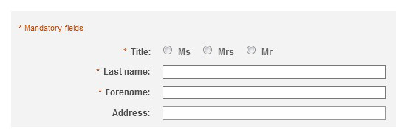
In this example, mandatory fields are indicated with an asterisk.

Provide help for entering data
Whenever the user is expected to enter values in a specific format in a form field, this should normally be indicated to the user.
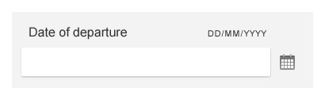
In this example, the format required for the date of departure is specified close to the field.
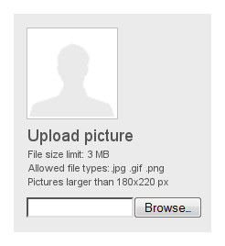
In this example, information concerning the format and size of the document
is provided before the document is sent.
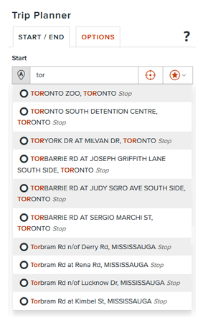
Auto-completion is another way of providing field-level help to the user.

Provide explicit error messages and suggestions for correcting errors
Whenever there is a possibility that a form returns errors, the following items must be provided:
- Explicit error messages.
- Suggestions for correcting errors.
These items must be positioned in one of the following places:
- At the beginning of the form.
- At the level of each form field.
- In both places at the same time.
Error messages must be explicit. In other words, the user must understand the cause of the error and be able to identify the field, just by reading the error message.
Suggestions for correcting errors that are caused by entering data in an incorrect format must be provided.
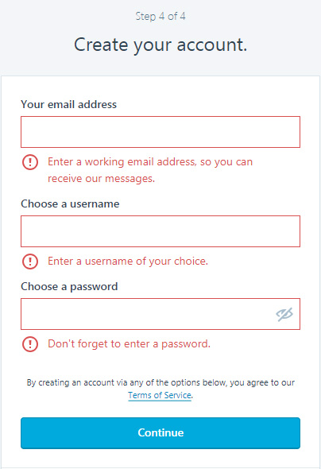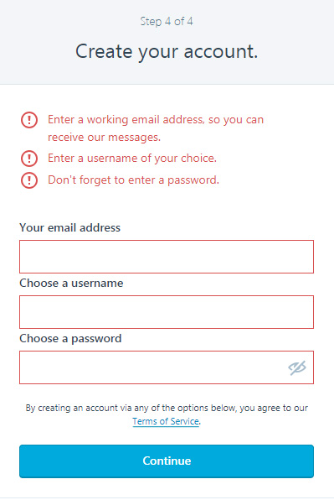
In the two examples above, the error messages are thorough
and are accompanied by suggestions for correcting the errors.
Warning
Error messages should not disappear automatically. Messages should only disappear on a user action (closing button, new page, new form submission, etc.)

Provide a confirmation message
Whenever a form is validated successfully, a confirmation message must be provided. This message must remind the user of the action that has been executed.
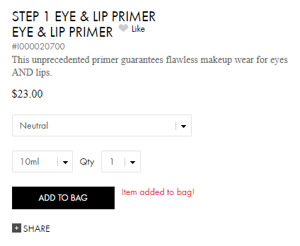
Following the addition of an item to the shopping bag,
a confirmation message is clearly displayed on the screen near the « ADD TO BAG » button.
Warning
Confirmation messages should not disappear automatically. Messages should only disappear on a user action (closing button, new page, new form submission, etc.)
Note
In some circumstances, a confirmation message is not necessary, as the page displayed after submitting the form makes the result of the action obvious. For example:
- A login form that sends the user to a "User profile" page.
- A "Go to next step" button that sends the user to the next step in a form with multiple steps.
- A comment form that sends the user to the comment posted.
- Etc.

Provide a way of returning to the previous steps on forms with multiple steps
For each form with multiple steps, the following information must be provided:
- A way of returning to the previous steps.
- The total number of steps.
- Cues to identify the current active step.

In this form, 3 steps are identified and users can click on the title of step 1
to go back from the subsequent steps.

Provide a summary of all the data entered before final submission of the form
For each form containing multiple steps, a summary of all the data entered must be proposed to the user before the final submission of the form.
From the summary, it must be possible either to directly edit all the values, or to return to the previous steps to do so.
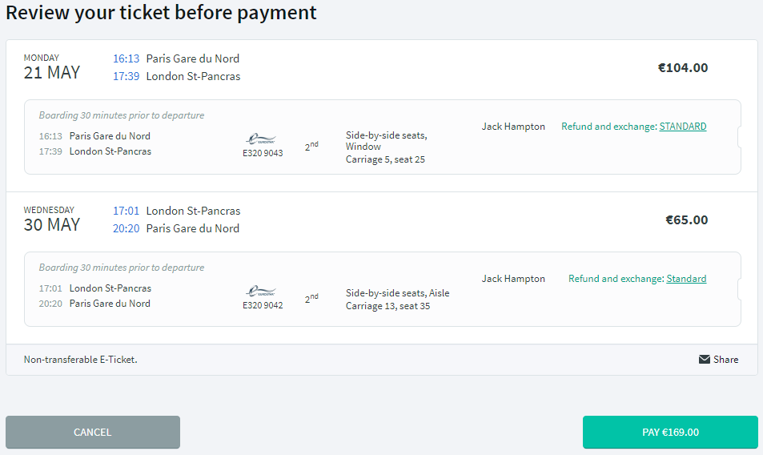
After having filled in the form, a summary is shown to the user,
who can modify the values before paying.

Provide a security test that is a logical test rather than a CAPTCHA
CAPTCHAs were designed to block spambots.
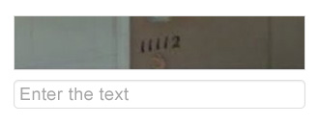
Example of a graphical CAPTCHA.
To confirm a CAPTCHA, the user has to decipher a visual or audio code and type it in the corresponding field.
In terms of accessibility, CAPTCHAs are problematic because they can be too complex for many users, particularly those who are blind, visually impaired or dyslexic.
Security tests should therefore be more accessible to users, and be replaced by logical tests, for instance.

Radio button to be modified (solution #1)
In this solution, a request is included in the form, such as: “Please select the “Yes” button”, placed next to two radio buttons: “Yes” and “No”.
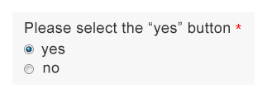

Simple question (solution #2)
In this solution, a simple question is added to the form, such as:
- What is the color of the sky when it's sunny?
- What is the plural of "fish"?
- What is the color of the white house?

Mathematical question (solution #3)
In this solution, a basic mathematical question is added to the form, such as:
- What is 8 minus 2? (in digit)
- What number is between 45 and 47? (in digit)
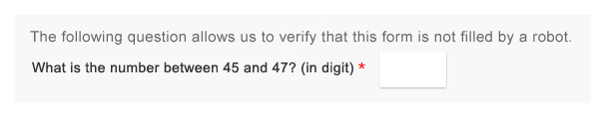
Example of a security test presented as a basic mathematical question.
Tip
- Recommended practice is to include a sentence before the logical test that specifies : « This question confirms that the form is not completed by a robot. »
- A good accessibility practice that is particularly useful for people with cognitive impairments is to provide a solution to reload the text or mathematical question.
- Another good accessibility practice is to offer the possibility to contact a person from the company, if the user is having problems completing the logical test. This could be done by providing a link, such as: « Please contact us if you have any problems answering this question » next to the test.
Note
The best solution is to completly do without a CAPTCHA or logical test, and to use one or more of the following solutions that are more "transparent" for the user:
- A hidden field in the form that should remain blank (the “Honeypot” technique).
- An email confirmation.
- A preview/confirmation page before sending the form.
- A test on the time spent filling in the form.
- An anti-spam filter system on the server.
Warning
If it is not possible to use a logical test or one of the other solutions above, provide an alternative for CAPTCHAs that are only sound or only visual tests.

Provide an alternative to each CAPTCHA that is only a sound or only a visual test
For each CAPTCHA (anti-spam system) that is only a sound or only a visual test, an alternative must be provided.
For example:
- A sound alternative for a visual CAPTCHA.
- A visual alternative for a sound CAPTCHA.
- A text alternative in the form of a simple question for a sound or visual CAPTCHA.
- Etc.
Note
For each CAPTCHA, provide a method for reloading the content, because it is often difficult for users to understand it the first time it appears.
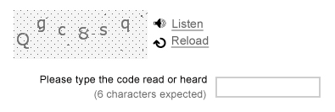
In this CAPTCHA, the link “Listen” provides the user with a sound version of the CAPTCHA.
Tip
Good practice is to provide, in addition to the reload solution, information on how to contact the website manager, if the CAPTCHA cannot be typed in (a link to the “Contact” page, a phone number, etc.).
Warning
CAPTCHAs are designed to block spambots that use more and more sophisticated techniques to circumvent them.
This means that it is increasingly difficult for users to decipher them. By definition, a CAPTCHA will never be fully accessible, so the best solution to ensure accessibility is to do without it or to prefer security tests presented as logical tests.

Multimedia

Provide a heading or summary for all video and audio content
To highlight each video, a heading and/or summary must be provided.
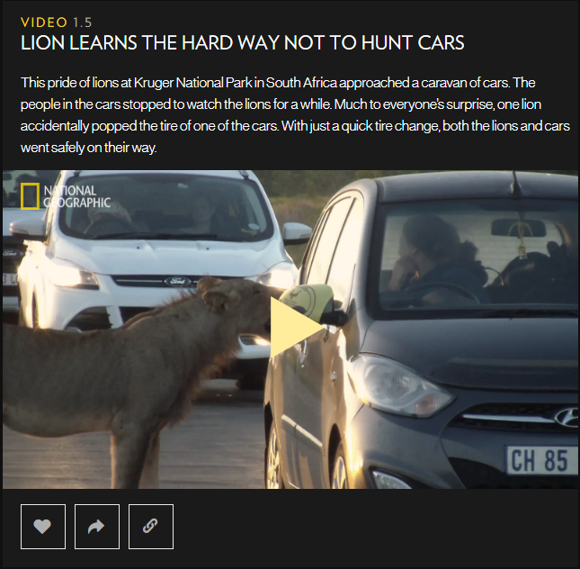
The video above is accompanied by a heading and a short introductory text.
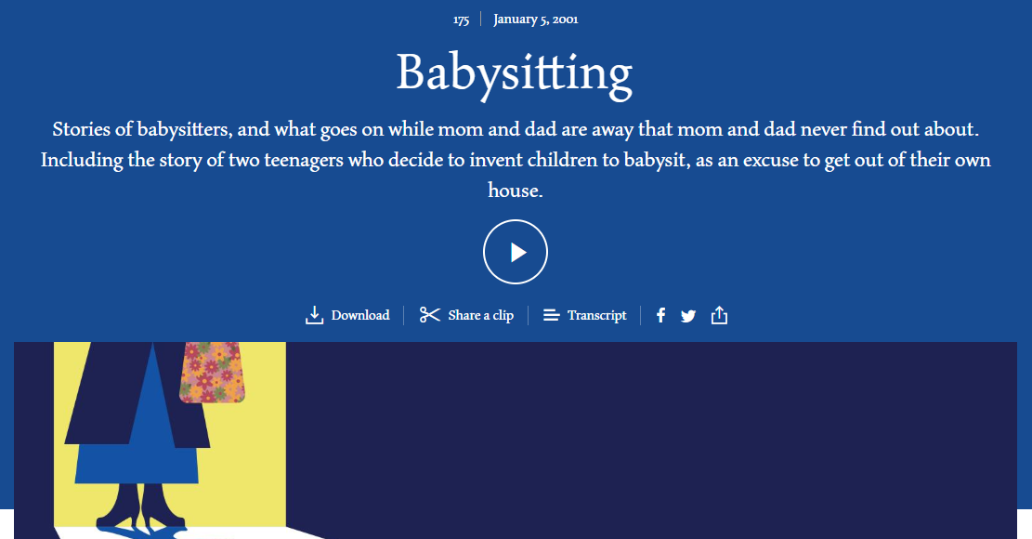
The audio content above is accompanied by a heading and a short presentation text.
Note
Audio content should also be presented with a title and description.

Provide a way of accessing the text transcript of all video and audio content
The user must have a way of accessing the text transcript of all video and all audio content.
This text transcript must be available:
- Either directly on the same page near the video or the audio content.
- Or on another page, available from a link close to the video or the audio content.
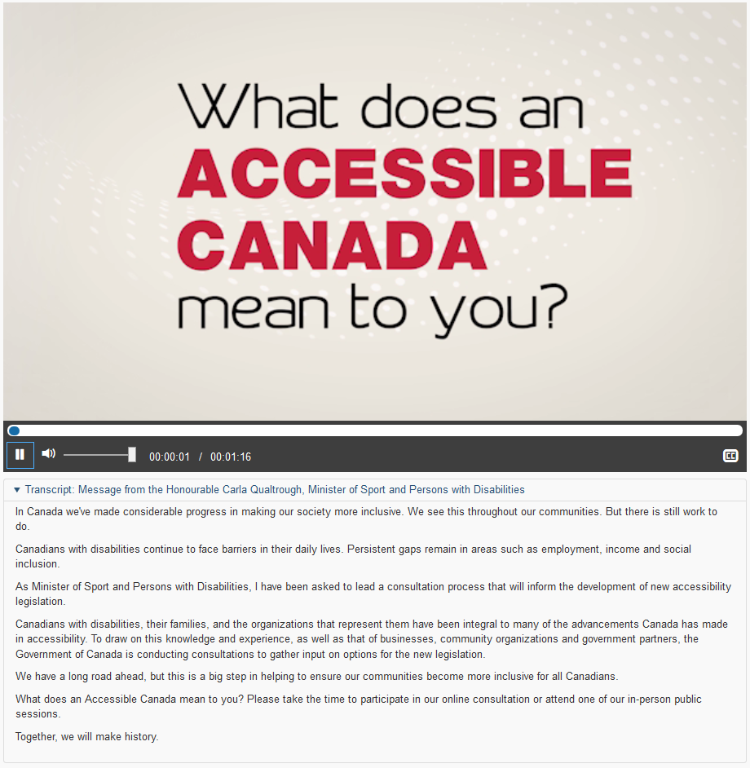
Example of a text transcript directly under the video.
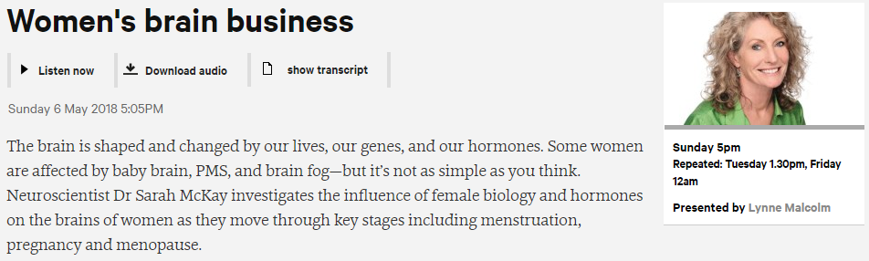
Example of a link to the text transcript of the audio content.

Provide a way of controlling the progress and volume of all video and audio content
The following controls must be included with all video and audio content:
- Progress controls, play/pause button and stop button.
- Sound controls: mute/unmute sound button and volume control button.
Tip
It is very useful to display information concerning the current position and total duration of the video or the audio content, and a method of moving forwards or backwards in the video (progress bar, fast forward/fast backward buttons, etc.).

Provide a way of displaying the closed captions
You must provide a way of displaying and hiding the closed captions for each video.
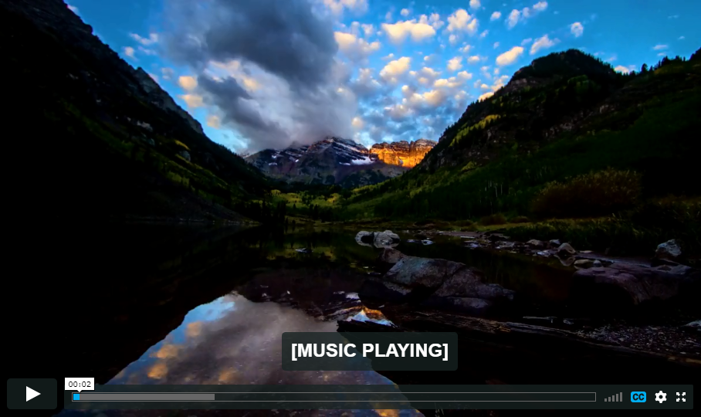
The “CC” button is used for activating the closed captions

Select a style for the captions that makes them readable
Whenever closed captions are displayed, the contrast between the text and the video in the background must be sufficient.
Tip
For example, add a black background for white closed captions, or a dark outline for clear text, in order to ensure readability in all circumstances.
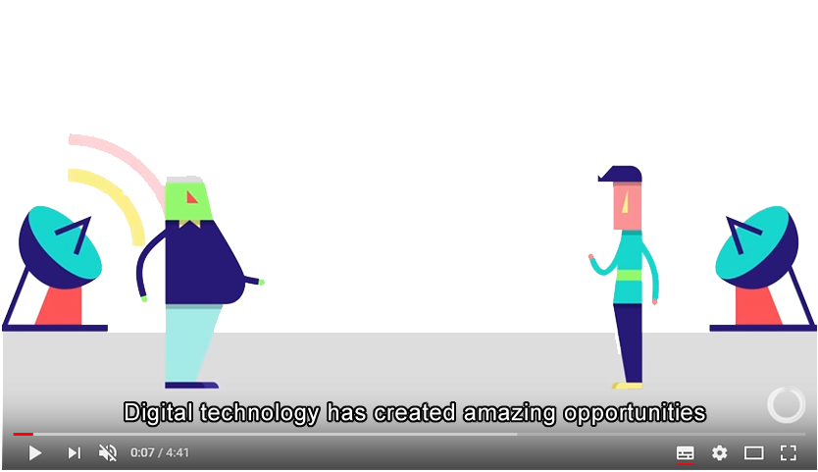
Closed captions with a white type and black outline, for example,
ensure that text is readable in all contexts.
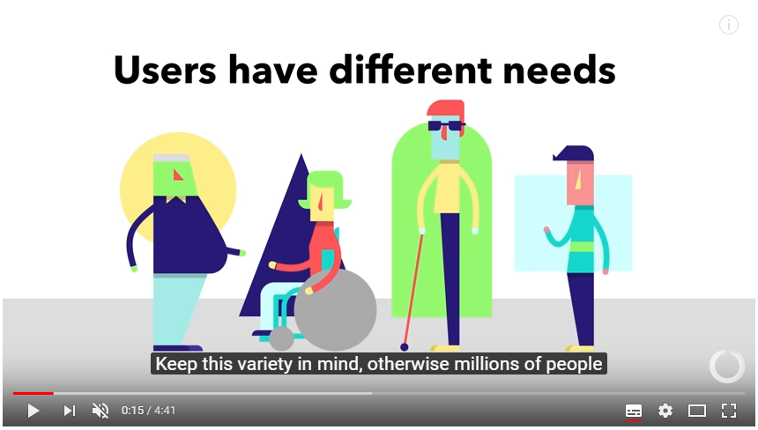
A background that is opaque or semi-transparent also ensures that the text is easily read.

Provide a way of activating the audio description
A way of activating or deactivating the audio description must be provided with each video.
Note
The audio description is the equivalent of closed captions for blind or visually impaired people. It provides oral commentary and narration for information that is only conveyed by images.
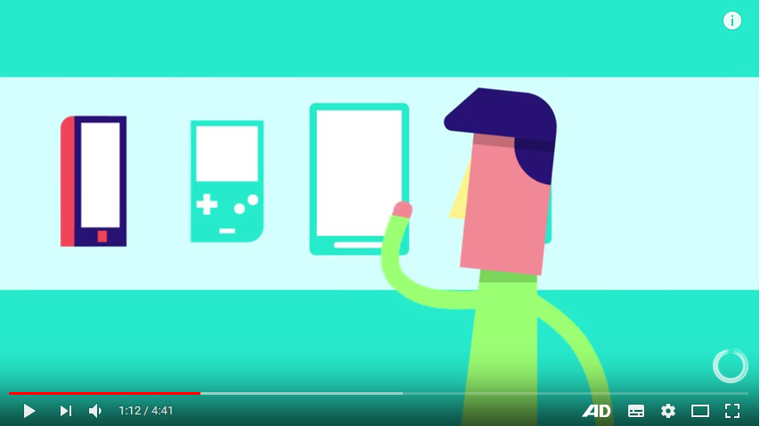
The "AD" button (for Audio Description) is used to activate the audio description.

Provide a method for stopping all animated content
You should provide a way of pausing and restarting all animated content (content that scrolls, blinks, moves, or is automatically updated, etc.).
Note
You do not need to provide a progress bar or pause/play button for animations that last less than 5 seconds.
Tip
If the page offers a lot of moving content, a good accessibility practice is to provide a system, at the top of the page, for pausing and restarting all the page movements.
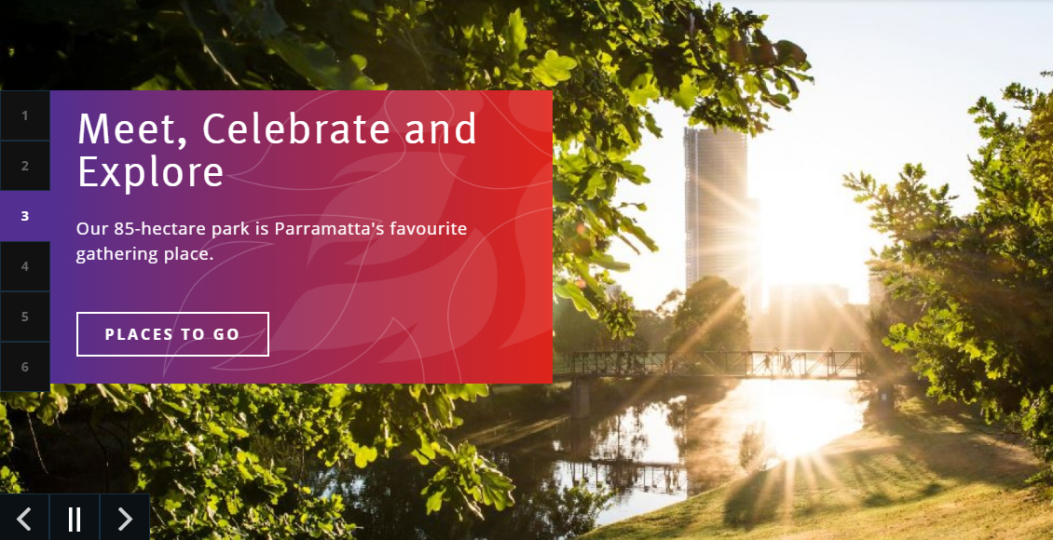
This animated carousel has a system for pausing the movement.
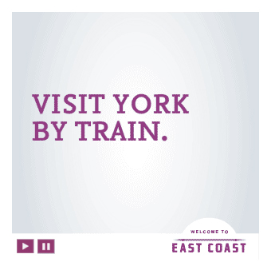
This advertisement is animated, and has a system for pausing the movement.

Do not automatically trigger the sound
Do not automatically trigger a sound that lasts more than three seconds.
It is strongly recommended not to include sounds that are triggered automatically. Some users will be disconcerted by a sound that is launched without any action on their part, and it may be difficult to find the source of the sound when several tabs are open. Other users will simply be blocked—users of voice synthesisers will no longer be able to continue navigating, for example.

Additional Guidelines
To keep this document practical and user-friendly, some of the accessibility recommendations of the WCAG have not been kept in the core of this document.
These criteria are rarely applicable in a web project or are of low priority.

To comply with level A (WCAG 2.0)
- Provide a heading or summary for all interactive content with information only perceptible through one of the five senses.
- Provide access to a text alternative for complex visuals.
- Limit the use of flash.
- Allow the user to control time limits on content consultation.
- Warn the user each time a link or button opens a new window.
- Make sure a new window does not open without the user's action.
- Information should not be conveyed by shape, size or position only.

To comply with level AA (WCAG 2.0)
- Provide a method for controlling the size of text.
- Provide a table of contents for pages with a large volume of content.
- Provide links to sibling pages, if required.
- Allow the control of personal, legal or financial data entered.

To comply with level AAA (WCAG 2.0)
- Provide a glossary to provide detail on complex content, if required.
- Indicate the pronunciation of words when their meaning is ambiguous in the context.
- Provide a method for reading the text content aloud.
- Limit the width of text to 80 characters.
- Provide line spacing of at least 1.5 times the text size.
- Provide paragraph spacing of at least 1.5 times the value of the line spacing.
- Ensure optimal contrast between the content and the background, or propose an alternative with sufficient contrast.
- Provide a method for customizing the text font and the display colours.
- Make sure time limits for completing a task are properly set.
- Allow the modification, update or recovery of all data typed in.
- If the authenticated session is interrupted, provide a means to recover all data typed in after re-authentication.
- Provide a thorough audio description for all multimedia content.
- Provide an interpretation in sign language for all multimedia content.

